
INDUSTRY REPORT
Sea & Coastal Freight Water Transport in the UK
May 2026

About

IBISWorld
IBISWorld specializes in industry research with coverage on thousands of global industries. Our comprehensive data and in-depth analysis help businesses of all types gain quick and actionable insights on industries around the world. Busy professionals can spend less time researching and preparing for meetings, and more time focused on making strategic business decisions.

Table Of Contents | Standard

1. About 4
Codes 4
Definition 4
Related Terms 4
What's Included 4
Companies 4
Related Industries 5
Additional Resources 5
2. At a Glance 6
Key Takeaways 6
Products and Services 7
Major Players 8
Key External Drivers 9
Industry Structure 9
SWOT 10
Executive Summary 10
3. Performance 12
Highlights 12
Key Takeaways 12
Performance Snapshot 13
Outlook 22
Life Cycle 25
4. Products and Markets 26
Key Takeaways 26
Products and Services 26
Major Markets 31
International Trade 34
5. Geographic Breakdown 35
Key Takeaways 35
Business Locations 36
6. Competitive Forces 40
Key Takeaways 40
Concentration 40
Barriers to Entry 42
Substitutes 43
Buyer & Supplier Power 45
7. Companies 47
Key Takeaways 47
Market Share 48
Companies 49
8. External Environment 58
Key Takeaways 58
External Drivers 58
Regulation & Policy 61
Assistance 63
9. Financial Benchmarks 64
Key Takeaways 64
Cost Structure 64
Financial Ratios 68
Valuation Multiples 71
Key Ratios 72
10. Key Statistics 73
Industry Data 73

1. About
https://my.ibisworld.com/uk/en/industry/H50.200/about

Codes
UK-SIC 2007 | 50.20

Definition
Companies in this industry transport bulk and non-bulk freight on vessels designed for the open sea or coastal waters. The industry includes scheduled and unscheduled activities, towing barges and oil rigs, and renting vessels with crew for sea transport.

Related Terms

20-FOOT EQUIVALENT UNIT (TEU)
A unit of measurement for containerised cargo capacity.

DRY BULK
Dry-bulk cargo typically includes commodities such as coal, steel and iron ore.

SHORT-SEA SHIPPING
Freight maritime activity that doesn't cross oceans, i.e. it remains on the same continent.

DEEP-SEA SHIPPING
Freight maritime activity that crosses oceans.

FREIGHT RATE
The price of shipping cargo. It is informed by the weight of the cargo and the distance it is travelling.

CARRIER BUNKER CHARGES
The floating part of sea freight charges, which represents additions due to oil prices.

What's Included
- Transporting liquid-bulk products
- Transporting containers
- Transporting dry-bulk products
- Transporting other general cargo

Companies
- BP Shipping Ltd
- P&O Ferries Division Holdings Ltd
- Evergreen Marine (UK) Ltd
- CMA CGM UK Shipping Ltd

Related Industries

Industries in the Same Sector
- Competitors:
  - Aircraft, Engine & Parts Manufacturing in the UK
  - Freight Air Transport in the UK
  - Freight Rail Transport in the UK
  - Freight Road Transport in the UK
- Complementors:
  - Boat Repair & Maintenance in the UK
  - Shipbuilding in the UK

International Industries
- Global Deep-Sea, Coastal & Inland Water Transportation
- Ocean & Coastal Transportation in the US
- Ocean & Coastal Transportation in Canada
- Water Freight Transport in Australia
- Water Freight Transport in New Zealand
- Sea & Coastal Freight Water Transport in Ireland
- Freight Transport by Sea in China

Additional Resources
- Department for Transport
- UK Chamber of Shipping
- Logistics UK

2. At a Glance
https://my.ibisworld.com/uk/en/industry/H50.200/at-a-glance
Revenue  £7.4bn  ’22-’27 ↑ 1.5 %  ’27-’32 ↑ 0.4 % | Employees  6,520  ’22-’27 ↑ 2.9 %  ’27-’32 ↑ 1.2 % | Businesses  643  ’22-’27 ↑ 1.3 %  ’27-’32 ↑ 0.6 %
Profit  £554.7m  ’22-’27 ↑ 2.3 % | Profit Margin  7.5%  ’22-’27 ↑ 0.3 pp | Wages  £303.4m  ’22-’27 ↑ 0.2 %  ’27-’32 ↑ 0.5 %

Key Takeaways

Performance
- Supply chain disruptions shake up the industry. Geopolitical issues and the lingering effects of Brexit have increased costs and created supply chain disruptions, making it tough for shipping companies to maintain profitability.
- Green initiatives reshape the market. Increasing environmental stringency, government-backed clean maritime projects and incentives for maritime decarbonisation are carving a sustainable path forward for freight water companies, boosting investment in low-carbon fuel alternatives.

Products and Markets
- E-commerce drives up retailers’ freight needs. The proliferation of online shopping has caused demand for water freight transport services from retailers and wholesalers to expand – and online sales don’t look like slowing anytime soon.
- Demand for transporting liquid-bulk products falls. As the UK shifts to renewable energy production and away from oil extraction, demand for transporting oil products is declining.

Products and Services
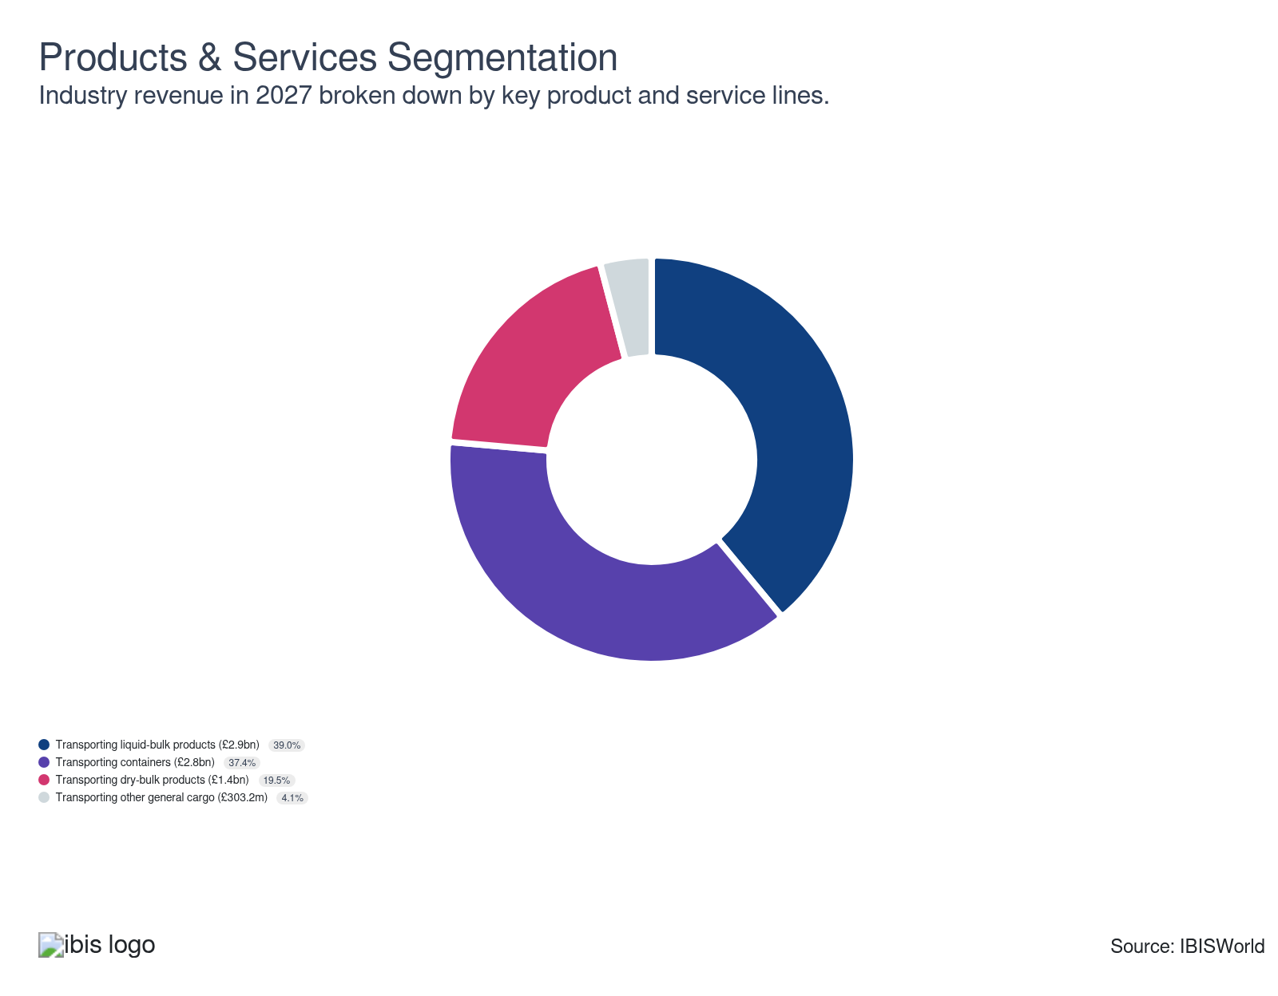

Major Players
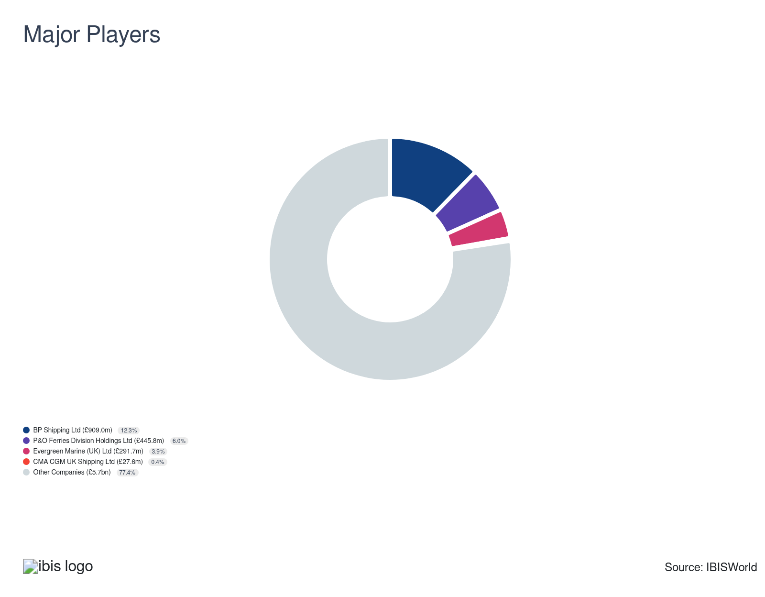

Key External Drivers
Key External Drivers | Impact
Total value of world trade | Positive
Demand from crude petroleum and natural gas extraction | Positive
Industrial production index | Positive
Real private consumption expenditure | Positive
World price of crude oil | Negative

Industry Structure
Characteristic | Level | Trend
Concentration | Low
Barriers To Entry | High | Steady
Regulation and Policy | High | Increasing
Life Cycle | Mature
Revenue Volatility | Low
Assistance | Low | Steady
Competition | Moderate | Increasing
Innovation | Moderate

SWOT
Strengths  High & Steady Barriers to Entry  Low Imports  Low Customer Class Concentration  Low Product/Service Concentration  High Revenue per Employee | Weaknesses  Low & Steady Level of Assistance  Low Profit vs. Sector Average  High Capital Requirements | Opportunities  High Revenue Growth (2021-2026)  High Performance Drivers | Threats  Low Revenue Growth (2026-2031)  Real private consumption expenditure

Executive Summary

Disrupted routes: Geopolitical shocks and environmental regulations reshape the industry’s growth prospects
Over the five years through 2026-27, the UK water freight industry's revenue is expected to rise at a compound annual rate of 1.5%, with revenue projected to gain by 3.2% in 2026-27 to reach £7.4 billion. Higher freight rates have been the principal driver of revenue growth, compensating for a period of genuine operational stress across the industry. Despite these pressures, profit is expected to remain steady at 7.5% in 2026-27, underpinned by elevated revenue per shipment and sustained investment in efficiency.
The onset of the US-Iran conflict in February 2026 has been the most disruptive near-term shock to the industry, effectively closing one of the world's most important maritime corridors and forcing widespread rerouting. Longer voyages have tightened vessel availability, pushing freight rates higher even as volumes have fallen. Fuel costs have surged, squeezing companies that cannot fully pass them on to customers. Companies have responded by adjusting sailing schedules, redeploying capacity and accelerating investment in port and transport technologies to maintain service reliability. These adaptations have helped protect revenue, but have done little to reduce the underlying cost burden.
Beyond the immediate geopolitical shock, the industry faces a set of longer-running challenges. The sustained decline in North Sea oil production has steadily eroded liquid bulk freight volumes over recent decades, removing a historically important revenue stream and forcing companies to diversify into other cargo segments. Brexit has also permanently raised the cost of doing business on EU-facing routes, adding fixed compliance expenses and contributing to a persistent labour shortage across the sector. Partly offsetting these headwinds, container shipping has shown clear signs of recovery, supported by the ongoing shift towards e-commerce and a gradual easing of inflationary pressures that had weighed on consumer demand.
Revenue is expected to increase at a compound annual rate of 0.4% over the five years through 2031-32, reaching £7.5 billion. Growth will be modest, as the costs of environmental compliance absorb an increasing share of capital. The extension of the UK Emissions Trading Scheme to the maritime sector and a proposed ban on new non-zero-emission vessel sales from 2030 will require sustained fleet investment throughout the forecast period. Progress on the UK-EU reset, particularly a prospective sanitary and phytosanitary agreement expected to ease border friction on agri-food trades from mid-2027, should provide some relief on EU-facing routes. The continued rise of e-commerce will keep container freight demand broadly resilient, while government-backed clean maritime funding is expected to accelerate the deployment of more efficient, lower-emission vessels over the longer term. Profit is expected to improve slightly, from 7.5% to 9% by 2031-32, as companies leverage innovation and a strategic focus on high-growth areas to drive profitability.

3. Performance
https://my.ibisworld.com/uk/en/industry/H50.200/performance

Highlights
Revenue  £7.4bn  2022-27 CAGR ↑ 1.5 %  2027-32 CAGR ↑ 0.4 % | Employees  6,520  2022-27 CAGR ↑ 2.9 %  2027-32 CAGR ↑ 1.2 % | Businesses  643  2022-27 CAGR ↑ 1.3 %  2027-32 CAGR ↑ 0.6 %
Profit  £554.7m  2022-27 CAGR ↑ 2.3 % | Profit Margin  7.5%  2022-27 CAGR ↑ 0.3 pp

Key Takeaways
- Supply chain disruptions shake up the industry. Geopolitical issues and the lingering effects of Brexit have increased costs and created supply chain disruptions, making it tough for shipping companies to maintain profitability.
- Green initiatives reshape the market. Increasing environmental stringency, government-backed clean maritime projects and incentives for maritime decarbonisation are carving a sustainable path forward for freight water companies, boosting investment in low-carbon fuel alternatives.

Performance Snapshot
Revenue: | ↑ 2022-27 Revenue CAGR +1.5%
Revenue  £7.4bn  ’22-’27 ↑ 1.5 %  ’27-’32 ↑ 0.4 % | 2027 Revenue Growth  ↑ 3.2 % | Revenue Volatility  Low
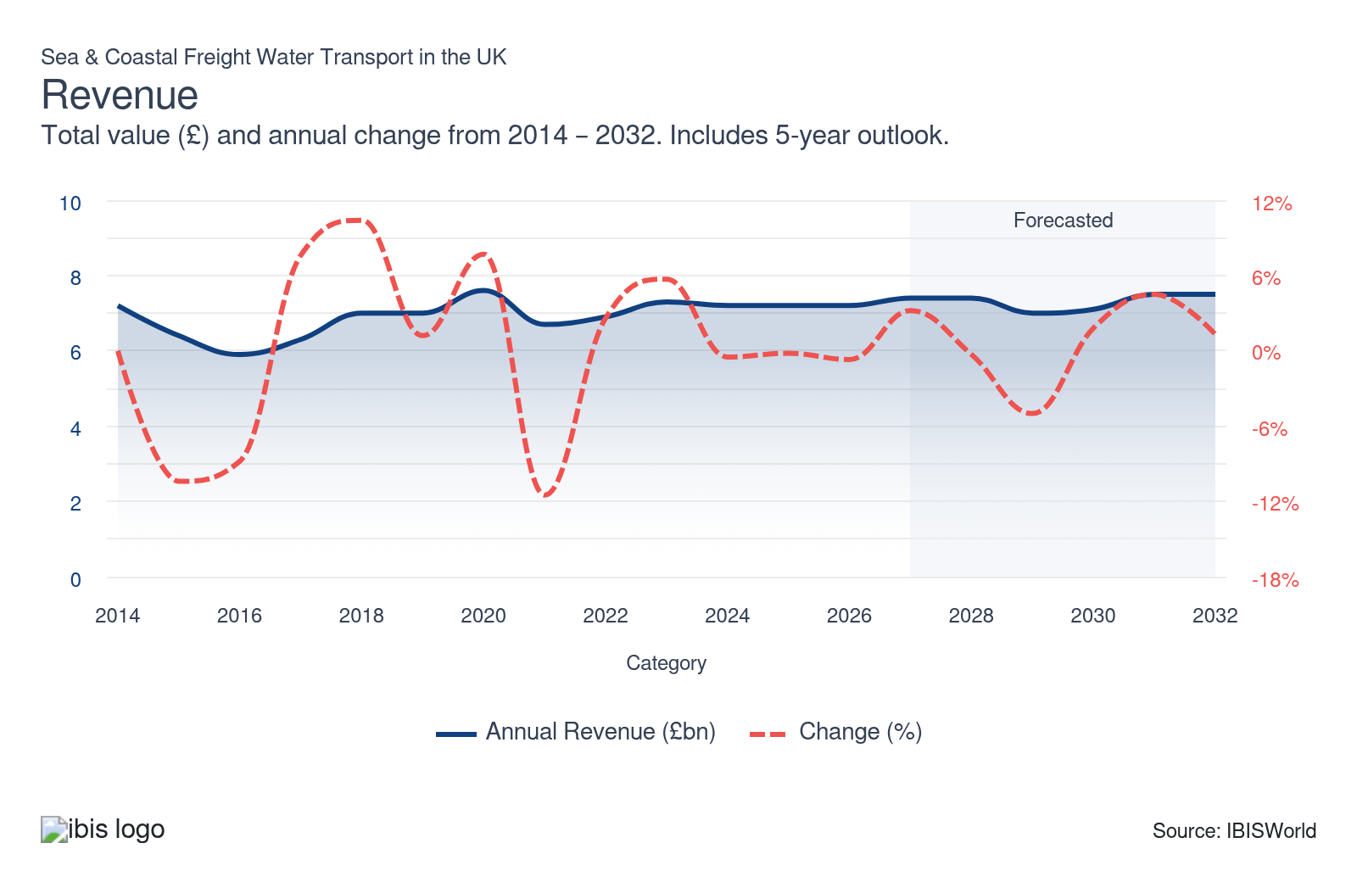
Employees: | ↑ 2022-27 Employees CAGR +2.9%
Employees  6,520  ’22-’27 ↑ 2.9 %  ’27-’32 ↑ 1.2 % | Employees per Business  10  ’22-’27 ↑ 1.6 %  ’27-’32 ↑ 0.6 % | Revenue per Employee  £1m  ’22-’27 ↓ 1.4 %  ’27-’32 ↓ 0.8 %
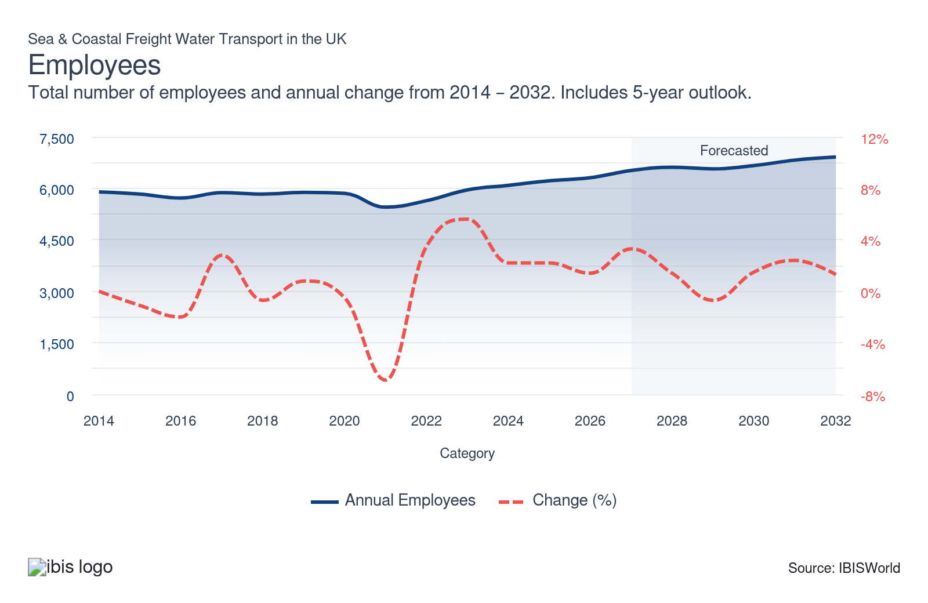
Businesses: | ↑ 2022-27 Business CAGR +1.3%
Businesses  643  ’22-’27 ↑ 1.3 %  ’27-’32 ↑ 0.6 % | Employees per Business  10  ’22-’27 ↑ 1.6 %  ’27-’32 ↑ 0.6 % | Revenue per Business  £11.5m  ’22-’27 ↑ 0.2 %  ’27-’32 ↓ 0.1 %

Profit: | ↑ 2022-27 Profit CAGR +2.3%
Total Profit  £554.7m  ’22-’27 ↑ 2.3 % | Profit Margin  7.5%  ’22-’27 ↑ 0.3 pp | Profit per Business  £862.6k
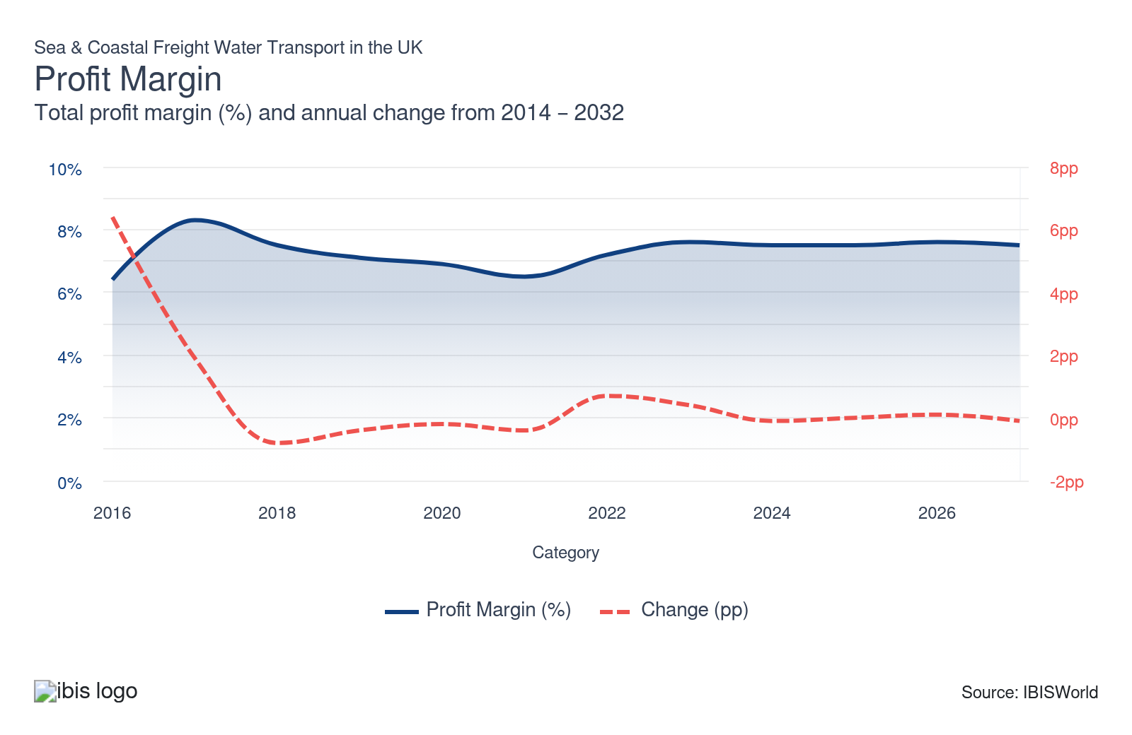
Current Performance
Current Performance

What's driving current industry performance?

Global conflicts continue to disrupt supply chains, threatening shipping operations
- The conflict between the US and Iran, which began in late February 2026, has materially disrupted the Strait of Hormuz, one of the world's most critical maritime chokepoints. According to UN Trade and Development (UNCTAD), daily vessel transits through the strait fell by around 97% in the weeks following the onset of hostilities, from an average of approximately 141 per day in early February to single figures by mid-March, severely disrupting the movement of energy, containerised goods and dry bulk cargo.
- The scale of the disruption is significant for shipping operators. In March 2026, BIMCO estimated that around 3% of global container volumes can no longer move freely, directly affecting approximately 5% of global ship demand. BIMCO's central forecast projects global ship demand may contract by around 5% in 2026 if Hormuz transits don’t resume, pointing to pressure on revenue growth through 2026-27.
- The conflict between the US and Iran has driven prices higher. The Strait of Hormuz normally handles around 25% of global seaborne oil trade, according to the International Energy Agency in February 2026. Disruption throughout the Strait is pushing up fuel costs across the industry. According to Ship & Bunker, bunker fuel prices rose to around US$982 (£730.12) per tonne as of 10 April 2026, almost doubling from US$499 (£371.01) on 12 January 2026. These prices have pressured industry profit in 2026-27.
- Despite declining shipping volumes, industry revenue is rising in 2026-27 as freight rates have increased, boosting revenue per shipment. After plunging through 2025, the Drewry World Container Index rose from US$1,927 (£1,432.72) per 40-foot container on 4 December 2025 to US$2,279 (£1,694.44) by late March 2026. These elevated rates are partly offsetting the impact of lower volumes and higher operating costs.
- Water freight companies have had to rethink their operations, adjusting their capacity and routes, modifying sailing schedules and investing more in technology to enhance port and transport efficiency. These efforts aim to maintain a resilient supply chain while ensuring a healthy bottom line. For example, in January 2026, CMA CGM reversed a short-lived return to the Red Sea and diverted its FAL 1, FAL 3 and MEX services back around the Cape of Good Hope, citing continued instability in the region.

A contraction in liquid bulk freight tonnage reshapes shipping patterns
- The industry has experienced a significant decline in liquid bulk freight tonnage over the past few decades. The Department for Transport (DfT) reports a 44% drop in liquid bulk cargo from 2000 to 2024. The DfT reported continued decline through 2025, with liquid bulk domestic traffic down 6% year-on-year in the final quarter, due to reduced crude oil and oil product transport. This decline has cut income opportunities for shipping companies in this product segment, prompting them to diversify into other cargo types and broaden their supply chains.
- Despite this volume erosion, companies have benefitted from a partial revenue offset on two fronts. The escalation of US-Iran tensions has tightened global crude supply, pushing oil prices higher and lifting revenue per liquid bulk shipment, sustaining revenue even as cargo volumes declined. Simultaneously, the UK's structural shift toward liquified natural gas (LNG) imports, accelerated by ongoing sanctions on Russian gas, has injected a new and growing sub-segment into liquid bulk flows. BP's 2023 nine-year agreement with Oman LNG to supply one million tonnes per year from 2026 exemplifies how long-term LNG contracts are creating durable freight demand that partly replaces lost crude oil volumes.
- Despite the significant decline in liquid bulk freight, the DfT reports a modest 1% fall in tonnage from all freight types in 2025. Tonnage in other product segments has performed stronger than liquid bulk. For instance, container shipping tonnage is showing strong signals of recovery. The DfT reported a 19% hike in container shipping in Q4 2025 compared to the previous year, driven by rising sea freight activity as income pressures ease. Consequently, shipping companies will need to remain agile, responding to market trends by capitalising on high-demand cargo types and exploring renewable energy product markets to sustain revenue growth.

Brexit continues to affect demand and costs
- Brexit has transformed temporary administrative hurdles into permanent operating expenses for UK water freight operators. With the January 2025 enforcement of the Border Target Operating Model, which brings full Safety and Security declarations for all EU imports, compliance with strict digital customs checks has become a fixed cost. Freight companies now face strict compliance thresholds; non-compliant shipments trigger automatic delays, pushing companies to invest heavily in customs-specialised staff and software, effectively baking these higher costs into their freight rates.
- Post-Brexit border frictions have fundamentally altered trade flows, with complex customs regimes causing delays and prompting many shippers to avoid the UK altogether. Ireland-UK Ro-Ro freight volumes dropped by 60% from 2021 to 2024, while Ireland-France routes surged by 88% as shipping re-routes to bypass UK checks, as reported by PublicPolicy.ie.
- Brexit has also created a lasting skills crisis, with UK freight companies facing severe challenges recruiting experienced EU staff due to visa restrictions. In April 2026, the British Chambers of Commerce reported that 82% of UK transport and logistics businesses faced hiring issues.
- Despite recruitment difficulties, increased automation and strong revenue per unit have spared the industry from rising wage costs, with companies investing in operational technologies to maintain efficiency and protect profitability. For example, to drive operational efficiency in the UK market, CMA CGM launched its sixth global startup accelerator, ZEBOX UK, in Manchester in October 2023. The accelerator focuses on identifying technologies, like software applications, that can enhance operational optimisation to reduce costs, including fuel and wages.

Stringent environmental regulations push companies to upgrade fleets
- The UK government has strengthened environmental regulations, including the implementation of clean maritime plans and stricter emission standards, to help meet its net-zero target by 2050.
- Given the global scope of water freight transport, shipping companies need to stay informed about international environmental regulatory changes. Since January 2024, voyages between the UK and EU have fallen partly within the scope of the EU Emissions Trading System (ETS), which applies to 50% of emissions on voyages between EU ports and non-EU ports, including the UK. From 1 July 2026, the UK will separately extend its own UK ETS to cover domestic maritime emissions on UK domestic routes and in UK ports. UK shipping companies must comply with stricter environmental standards that require them to purchase emissions allowances to offset their carbon footprint, increasing operating costs.
- To manage ETS expenses, companies are adopting strategies that balance operational demands with sustainability goals. For instance, in 2024, Evergreen Marine partnered with Copenhagen Infrastructure Partners to explore the development of carbon-neutral e-fuels.
- The government’s £77 million Zero Emission Vessels and Infrastructure (ZEVI) competition, a match-funding initiative supporting research into clean maritime technology to help the industry reduce emissions, has helped to alleviate some of the costs associated with implementing emission-reducing technology. This fund operated until March 2025, encouraging water freight companies to develop innovative solutions for reducing emissions. For example, in 2023, Collins River Enterprises Ltd won funding to build and test a fully electric ferry on the River Thames between Canary Wharf and Rotherhithe.

What influences industry volatility?

The value of global trade plays a pivotal role in determining revenue
- Demand for freight water transport depends on trade levels, which are driven by domestic and global operating conditions. This introduces a level of volatility to revenue. However, the effects of changing global conditions are often offset by fluctuating freight rates, making the industry less volatile than the broader transport sector.
- Exchange rate-led export growth is expected to have driven up demand and revenue in recent years. Sterling has experienced sharp swings, with GBP/USD trading between roughly 1.27 and 1.34 in April 2025, according to Yahoo Finance, as tariff announcements from the United States and potential UK retaliation unsettled markets. This volatility translated into revenue swings for shipping companies, as export volumes and margins fluctuated in line with the pound’s value.
- Freight water companies that export to growing international markets can secure a steady revenue stream, boosting growth. This is particularly beneficial during economic downturns, as it guarantees consistent demand amid lingering inflationary pressures.

Heightened operating costs drive up freight rates, heightening revenue volatility
- Freight water companies face volatile operating costs. Heightened fuel prices, driven by global supply disruptions, inflate shipping expenses and constrain profitability. To protect profitability, companies pass on increased costs to customers through higher freight rates, enhancing revenue prospects.
- As supply disruptions eased in 2023-24, some water freight companies saw their rates stabilise. However, in the first half of 2024, rates began to climb due to the Red Sea crisis. This crisis is causing shipments to reroute, resulting in greater congestion, capacity shortages and increased costs, inciting volatility.
- Despite a general downward trend through much of 2025, freight rates rebounded sharply in early December 2025. The Drewry World Container Index rose by 7% year-on-year to US$1,927 (£1,432.72) per 40-foot container on 4 December 2025 and reached about US$2,279 (£1,694.44) by late March 2026, signalling that rate volatility has persisted into 2026. These increased rates are feeding through to revenue growth in 2026-27.
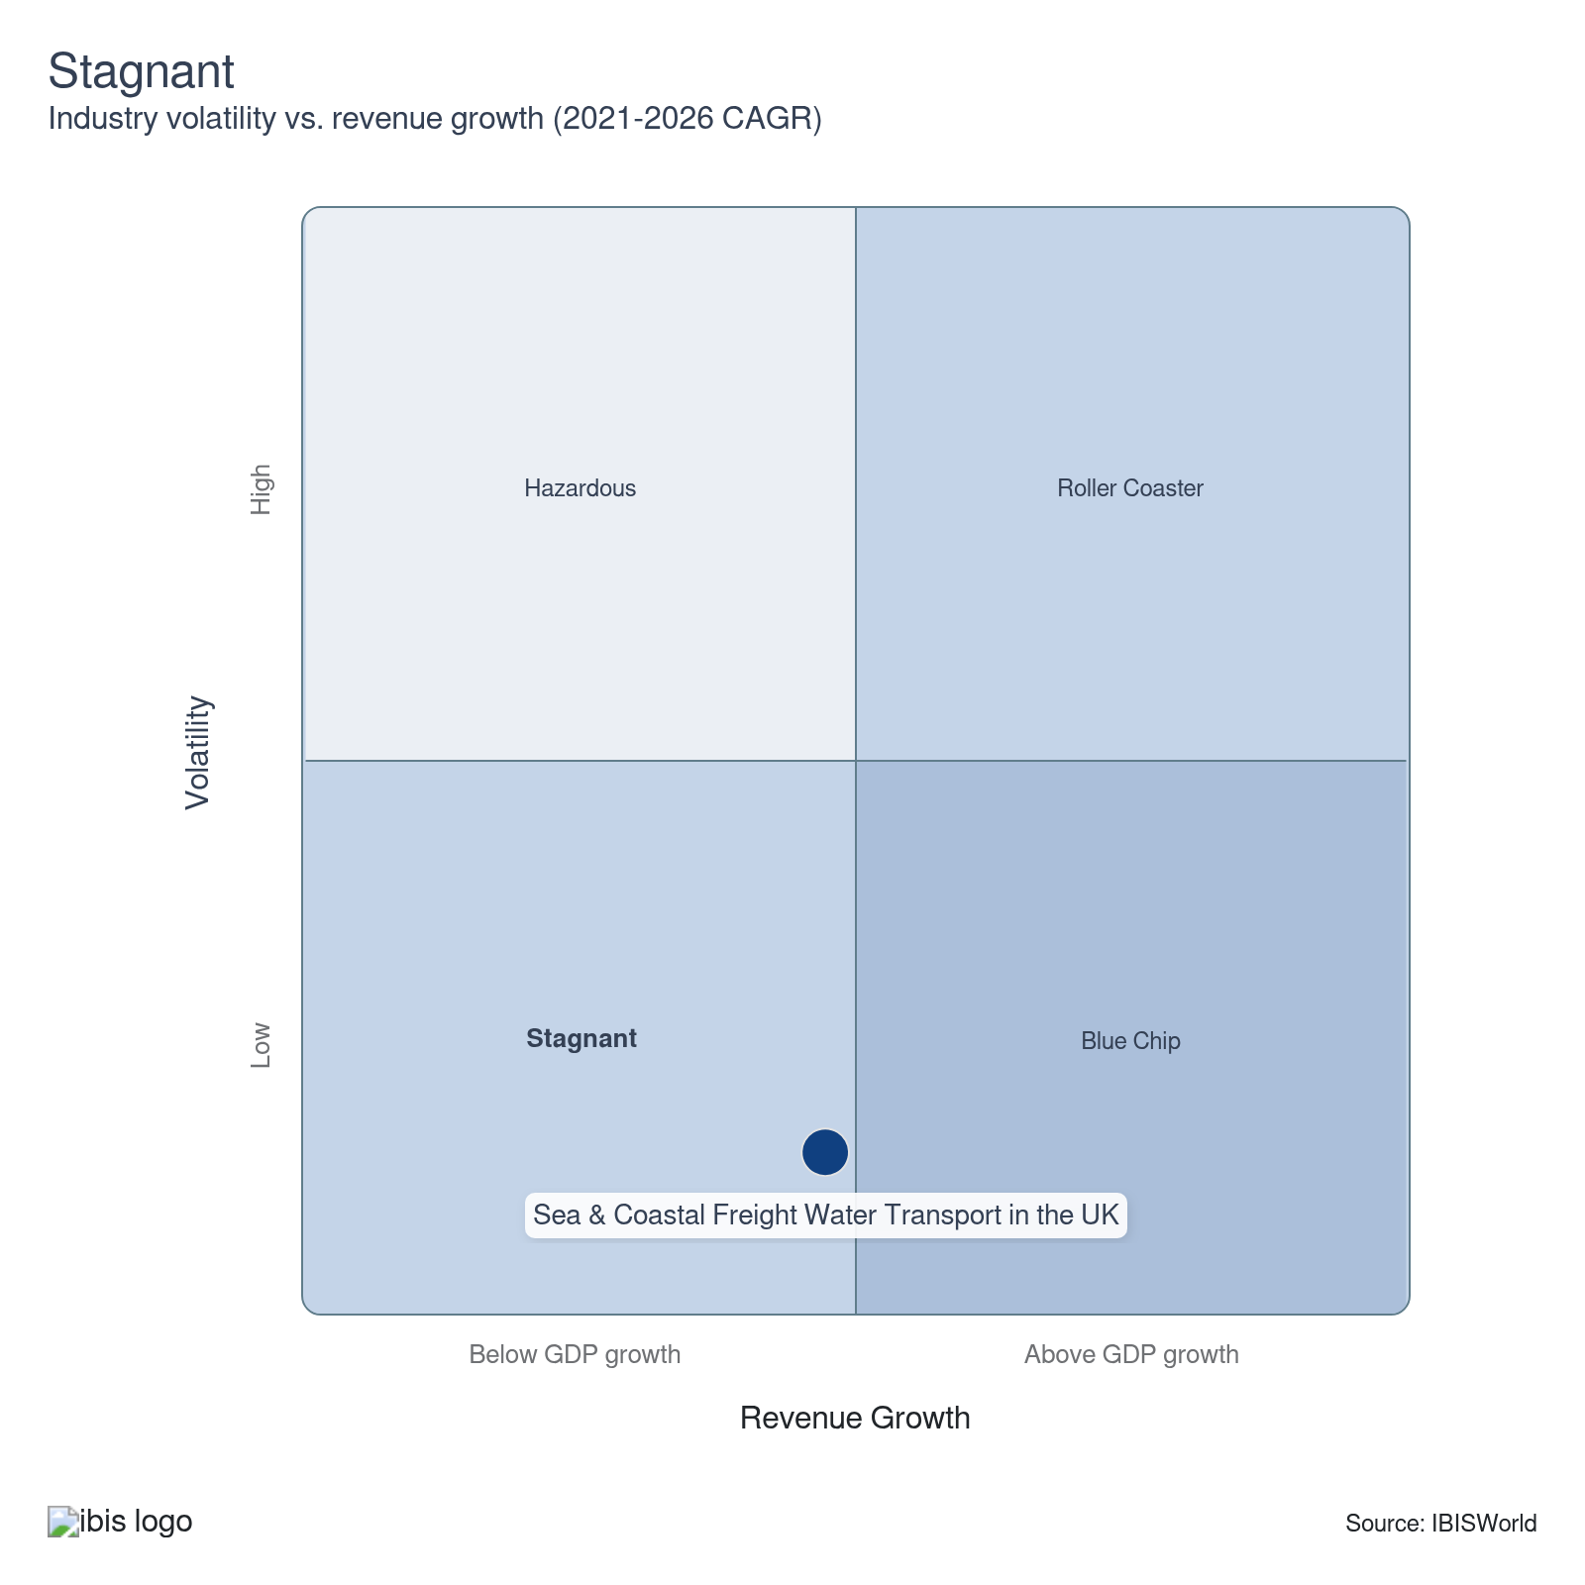

How do successful businesses overcome volatility?
Effectively manage risk
Understanding changing market conditions and managing risk through hedging fuel prices and securing forward contracts helps protect water freight companies from volatility.
Leverage economies of scale to lower unit costs
By streamlining operations for economies of scale, water freight companies can cut operating costs. This strategy helps maintain profitability amid challenging market conditions.
Outlook | ↑ 2027-32 Revenue CAGR +0.4%

What's driving the industry outlook?

E-commerce growth drives long-term container freight gains
- Rising online shopping penetration is set to continue to bolster demand for containerised freight, as most ecommerce merchandise is imported to the UK in shipping containers. According to the ONS, online sales accounted for 27.5% of all retail sales in February 2026, up from 25.9% in February 2025, indicating steady upward momentum. As consumer buying habits increasingly shift online, higher import volumes of a broad mix of goods will continue to underpin growth in container shipping revenue.
- The diversified nature of e-commerce cargo, spanning fashion, electronics, cosmetics, homewares and industrial components, provides resilience to the container shipping industry, helping shield it from cycles in any single downstream market. This mitigates volatility and supports a stable long-term outlook for container freight volumes.
- Easing inflationary pressures is set to restore consumer spending power. According to the Office for Budget Responsibility’s (OBR) March 2026 forecasts, inflation is expected to fall to 2.3% in 2026, from 3.4% in 2025 and reach the Bank of England’s 2% target from 2027. This disinflationary trend will lift real household disposable incomes, increase consumer confidence and drive greater discretionary consumption, sustaining demand for container-imported goods.
- Shipping lines are well-positioned to benefit from increased goods demand, especially in discretionary retail categories, like clothing and consumer electronics, heavily reliant on imported containerised goods. The OBR’s March 2026 forecast expects real wage growth of 0.7% between 2026 and 2030, enhancing spending capacity.
- To fully realise revenue opportunities from booming e-commerce imports, shipping companies can invest in expanding their container ship capacity and operational efficiencies. Expanding capacity will enable companies to increase freight volumes and capture greater market share as the structural trend towards online retailing accelerates.

The UK-EU reset will ease trade friction but introduce new compliance demands
- The UK-EU reset process, anchored by the May 2025 leaders' summit, is set to produce tangible changes to the operating environment for the sea and coastal freight industry. Negotiations are progressing on a Sanitary and Phytosanitary (SPS) agreement that will remove most routine border checks on animal and plant products moving between the UK and EU, including the elimination of Export Health Certificates. The UK government confirmed in March 2026 its intention for the agreement to take effect in mid-2027.
- Short-sea companies handling agri-food cargo stand to benefit most directly from the SPS agreement. This segment, which includes refrigerated and temperature-controlled services on routes to Ireland, the Netherlands and France, faces disproportionate border delays and certification costs relative to containerised manufactured goods. A mid-2027 SPS implementation should reduce dwell times and administrative costs per consignment for this segment, supporting revenue recovery on EU-facing agri-food trades and potentially attracting cargo that has shifted to road and air alternatives since Brexit.
- The reset will also bring new compliance obligations. At the May 2026 summit, the UK and the EU committed to working toward linking their respective emissions trading systems (ETSs). A linked carbon market will create a single pricing environment for vessels operating across both jurisdictions. This would reduce the competitive distortion caused by divergent carbon costs on cross-Channel routes. However, ETS linkage remains a medium-term ambition, not an imminent commitment. Even so, companies that invest early in fuel-efficiency and low-emission vessel upgrades will be better positioned to manage compliance costs as the regime tightens over the forecast period.
- Progress on the reset has been uneven and risks delay. Logistics UK noted in March 2026 that border friction was worsening further in the absence of a finalised SPS agreement. UK shipping companies can closely monitor progress on the SPS agreement and prepare now for both the operational benefits it will bring to agri-food and short-sea trades and the increased regulatory alignment requirements that will accompany the dynamic adoption of evolving EU standards over time.

Digitalisation and artificial intelligence (AI) will continue to transform water freight transport
- The adoption of advanced digital technologies, including real-time tracking and automation, is expected to swell as companies respond to rising input costs, particularly fuel and labour, over the coming years. These investments will aim to streamline operations, improve asset utilisation and reduce manual intervention, helping to minimise overall operating expenses even as underlying costs continue to expand.
- Digital freight platforms and AI-driven logistics are becoming industry standards. Water freight companies will increasingly adopt blockchain technology to improve the transparency, security and traceability of maritime transactions. Amid the evolving post-Brexit landscape, it's crucial for UK shipping companies to manage documentation and customs compliance effectively. Integrating blockchain technology can streamline and enhance the efficiency of these processes.
- The government has committed £448 million of clean-maritime R&D funding between 2026 and 2030, alongside over £700 million of private investment, to fund new rounds of the Clean Maritime Demonstration Competition and smart-shipping trials. In March 2026, ministers also announced a package worth about £271 million for Clean Maritime Demonstration Competition Round 7. This multi-year package is expected to accelerate the deployment of low- and zero-emission, digitally enabled vessels and port infrastructure, supporting productivity and growth in the water freight industry.
- Water freight companies are poised to leverage government initiatives to innovate their operations, especially amid severe supply chain issues. While efforts aim to enhance efficiency and reduce escalating overheads, the benefits will take time to manifest, underscoring the need for a long-term commitment to improving freight transport operations. Key priorities include adopting just-in-time arrival systems to cut idle time and fuel use, alongside deploying AI-driven predictive maintenance to prevent costly vessel downtime. Companies are also expected to invest in more automated cargo handling at ports, which should gradually accelerate turnaround speeds and support more reliable freight services.

Environmental regulations tighten, placing greater pressure on shipping companies
- Environmental regulation is intensifying as a result of the DfT's long-term plan for freight, published in June 2022 and the Maritime Decarbonisation Strategy released in March 2025. Together, these underline the government’s commitment to lowering the environmental damage of coastal freight shipping. Plans include achieving net-zero greenhouse gas emissions for the domestic maritime sector by 2050, driven by a proposed ban on the sale of new, non-zero-emission vessels from 2030 onwards. Measures are likely to include incentives for maritime decarbonisation and extension of Renewable Transport Fuel Credits.
- The expansion of the UK Emissions Trading Scheme (UK ETS) to include the maritime sector, announced in November 2024, is taking effect. Domestic maritime emissions from ships of 5,000 gross tonnage and above will enter the scheme from July 2026, with offshore vessels following from January 2027. This will put a direct carbon price on voyages between UK ports, incentivising shipping companies to adopt low-carbon fuels and implement fuel-efficient technologies in the near term. The October 2024 Maritime Minister investment of up to £9 million has already laid the groundwork, funding green shipping corridor feasibility studies and smart shipping trials, providing a pipeline of deployable innovations that shipping companies can draw from as compliance obligations tighten.
- The 2025 Maritime Decarbonisation Strategy sets a clear trajectory. At least a 30% cut in UK domestic maritime greenhouse gas emissions by 2030 and 80% by 2040, with net zero by 2050. These milestones will require sustained capital investment in zero- and low-emission vessels and fuels well before the end of this decade and the government is expected to direct additional funding and regulatory support to shipping companies as compliance deadlines approach.
- To stay ahead of growing environmental regulation, companies can prioritise upgrading the oldest, highest-emission vessels first to maximise compliance efficiency. By doing this, they can also capture early-mover advantage in gaining access to green corridors and government-backed decarbonisation funding schemes.
Life Cycle | Mature

Why is the industry mature?

Contribution to GDP
The industry is growing at a faster rate than the overall economy, driven by its fundamental role in transporting goods both domestically and internationally. The government's Waterborne Freight Grant Scheme aims to enhance growth opportunities in the industry by promoting a shift towards more environmentally friendly water freight transport.

Market Saturation
Market saturation has shifted slightly amid economic downturns, causing some water freight companies to experience significant drops in revenue, notably Evergreen Marine (UK). Overall, the industry is moderately saturated due to limited port capacity and regulatory challenges, exacerbated by increasing environmental and labour disputes.

Innovation
Wind-assisted propulsion, hybrid-electric vessels and AI-driven logistics are revolutionising operations. Recent innovations aim to boost efficiency by reducing crew sizes and enhancing loading and unloading times, focusing on operational improvements. These advancements streamline processes, offering substantial operational gains to shipping companies.

Consolidation
Excess capacity and increasing international competitive pressures have spurred a process of consolidation in both local and global shipping operations. This has been supported through a proliferation of consortia, which have enabled global carriers to create a web-like structure of interlinkages.

Technology & Systems
The industry is characterised by a moderate level of technological change. Over the past decade, water freight companies have increasingly used satellite communication systems, creating the Global Maritime Distress and Safety Signals (GMDSS) system. Also, the proliferation of digital route management technologies is helping freight water transport companies to improve operational efficiencies.

4. Products and Markets
https://my.ibisworld.com/uk/en/industry/H50.200/products-and-markets
Largest Market  £2.9bn  Transporting liquid-bulk products | Product Innovation  Moderate

Key Takeaways
- E-commerce drives up retailers’ freight needs. The proliferation of online shopping has caused demand for water freight transport services from retailers and wholesalers to expand – and online sales don’t look like slowing anytime soon.
- Demand for transporting liquid-bulk products falls. As the UK shifts to renewable energy production and away from oil extraction, demand for transporting oil products is declining.

Products and Services
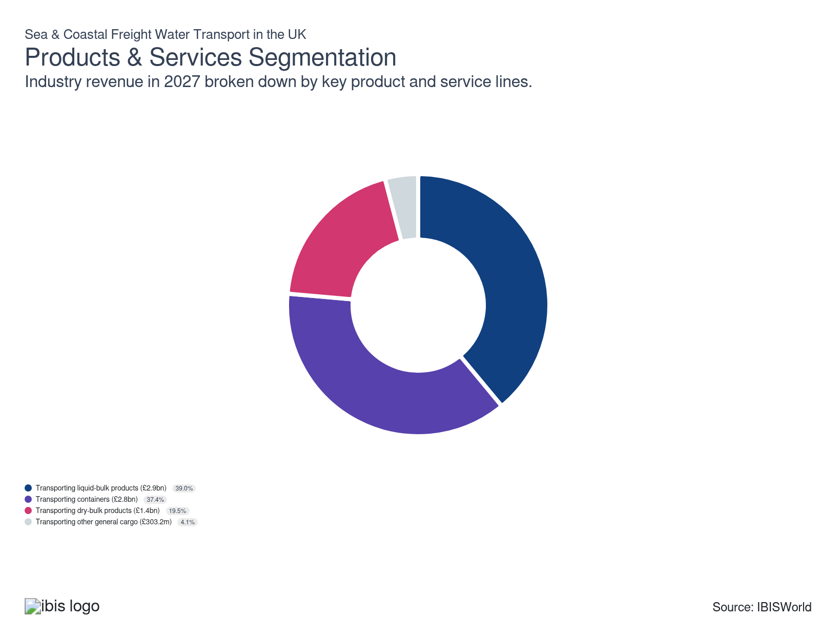

How are the industry’s products and services performing?

Decarbonising the energy mix dampens demand for liquid-bulk products
- Liquid bulk refers to liquids or liquid gases, like oil, chemicals and liquefied natural gas (LNG), transported in specialised tanks. Due to their size and load capacity, ships are more efficient than road or rail for transporting these products.
- Following a general decline in liquid bulk traffic through UK major ports since 2000, the Department for Transport (DfT) reported that liquid bulk tonnage through UK major ports fell by 6% in Q4 2025 compared to Q4 2024, partly driven by the full closure of the Finnart Oil Terminal at Clyde. This dip mirrors the UK's shift to renewable energy sources like wind and solar, as well as reduced North Sea oil extraction, which have kept liquid bulk volumes below historical levels.
- Rising oil prices, fuelled by the US-Iran conflict, are significantly boosting revenue from liquid bulk transport in 2026-27 despite declining volumes. According to the Financial Times, Brent crude prices rose by 57.7% in the years to 13 April 2026, amid difficulty transiting the Strait of Hormuz.

Constrained consumer spending dampens demand for container shipping
- Containers of goods are moved between the UK and the continent as part of intermodal supply chains for large wholesalers and retailers. Containers can be loaded onto ships using conventional lift-on/lift-off (Lo-Lo) services or can be loaded onto roll-on/roll-off (Ro-Ro) vessels.
- Consumer spending influences demand for container shipping. Income pressures in 2026-27 are tightening budgets, reducing revenue in this segment. However, growth in e-commerce has boosted demand for efficient bulk deliveries, supporting container transportation services.
- The DfT reports a 19% year-on-year hike in container shipping and a 1% rise in Ro-Ro freight tonnage, respectively, in Q4 2025. This growth is attributed to increased sea freight activity at London Gateway following the launch of a new £350 million, all-electric fourth berth in November 2024, which has expanded the port's capacity to handle larger vessels.

Growing demand for moving biomass drives up revenue from transporting dry-bulk products
- Dry-bulk products include coal, ores, scrap metal and agricultural products that aren't liquid and can be carried freely inside dry-bulk cargo tanks. The majority of dry-bulk goods being transported are being imported into the UK.
- With the UK's closing its last coal-fired plant in October 2024, coal transportation has declined. This drop has been offset by a rise in biomass transportation, reflecting a shift to renewable fuels.
- Dry bulk tonnage climbed 7% year-on-year in Q4 2025, according to the Department for Transport. This surge came as Biomass power generator, Drax, reported record power and pellet production in 2025, lifting biomass inflows through Immingham Port.
- Demand for transporting cement and aggregate dry-bulk is driven by construction output. Construction output grew by 1.8% in 2025 according to the ONS, increasing demand for dry bulk transport.

Transporting other general cargo offers a minor source of revenue
- Other cargo includes breakbulk, forestry products, iron and steel items and containers less than 20 feet long. Breakbulk cargo comprises of goods shipped in individual pieces transported in crates, boxes, bags and barrels, requiring separate handling.
- Freight water companies handle one-off speciality items that are too big or heavy to be moved by road or rail over long distances (e.g. mining and construction equipment and ship parts).
- Demand for other general cargo has been constrained by weak industrial output and budget pressures limiting new capital projects. The UK government announced in March 2026 that steel import quotas will be cut by 60% from July 2026, with tariffs of 50% on volumes above quota, which is likely to reduce the volume of steel imports transported through UK ports in 2026-27.

What are innovations in industry products and services?

Advancements in satellite and communication systems improve safety and efficiency
- The Global Maritime Distress and Safety System (GMDSS) is a comprehensive maritime communication network designed to enhance safety and streamline rescue operations for ships, boats and aircraft in distress. It manages emergency and distress signals, as well as routine communications between vessels and between vessels and shore stations.
- The adoption of digital route management has accelerated significantly, helping to shorten journey times. Companies are increasingly leveraging Internet of Things (IoT) technology to connect onboard devices, sensors and systems. These technologies allow the crew to collect and analyse data in real time, facilitating improved decision-making to enhance operational efficiency, safety and environmental sustainability. For example, IoT technology can be used for predictive maintenance and fuel optimisation.

Environmental regulation spurs significant innovation
- Freight water companies have made significant investments to adapt their operations to meet increasingly stringent emissions regulations.
- Companies are using biofuels and proactive cleaning to reduce drag, cutting the energy required to propel vessels. For example, in 2022, BP began trials of biofuels to reduce carbon emissions from shipping.
- Shipping companies are actively developing low-carbon solutions, like battery technology, to reduce energy demands and emissions. Electric and hybrid ships equipped with energy storage systems are gradually entering the market. These vessels lower fuel costs and maintenance needs while also enhancing reliability and responsiveness by storing energy for periods of high demand. In 2024, Innovate UK awarded £20 million to a UK consortium to build the first large service operation battery-powered vessels. These zero-emission ships are expected to set sail by 2028.
- Improving fleet efficiency will prove pivotal in attracting clients as rail and air freight companies also increase investment in sustainability initiatives.

Wind propulsion systems offer more opportunities to reduce emissions
- Sea and coastal freight transport companies are actively working to improve fuel efficiency and reduce carbon emissions. As technological advancements and ship modifications emerge in the upstream manufacturing sector, companies are adopting innovations like wind propulsion systems to meet their sustainability targets.
- Wind propulsion systems employ technologies that capture wind energy, lessening a ship's fuel dependency and cutting carbon emissions. These systems can be added to existing vessels or integrated into new builds, offering flexible adaptation options for different shipping companies.
- In October 2024, GT Wings, a company that develops wind propulsion technologies, received a grant from the UK government to enhance its AirWing system. This grant will support the integration of AI-driven, self-learning control systems to optimise the system's performance. The first AirWing was assembled at the MMS Docks in Hull and was trialled in March 2025, with GT Wings reporting it showed a 5-8% fuel saving.

What products or services do successful businesses offer?
Ensure prompt delivery to market
Timely deliveries are crucial in freight water transportation to ensure the supply chain is completed. Quick deliveries build trust and reliability among clients, leading to more business opportunities.
Invest in new technology to enhance operational efficiency and quality
Leveraging innovative technology improves fuel efficiency, reduces operational costs and enhances service quality, providing a competitive edge to freight water companies.

Major Markets
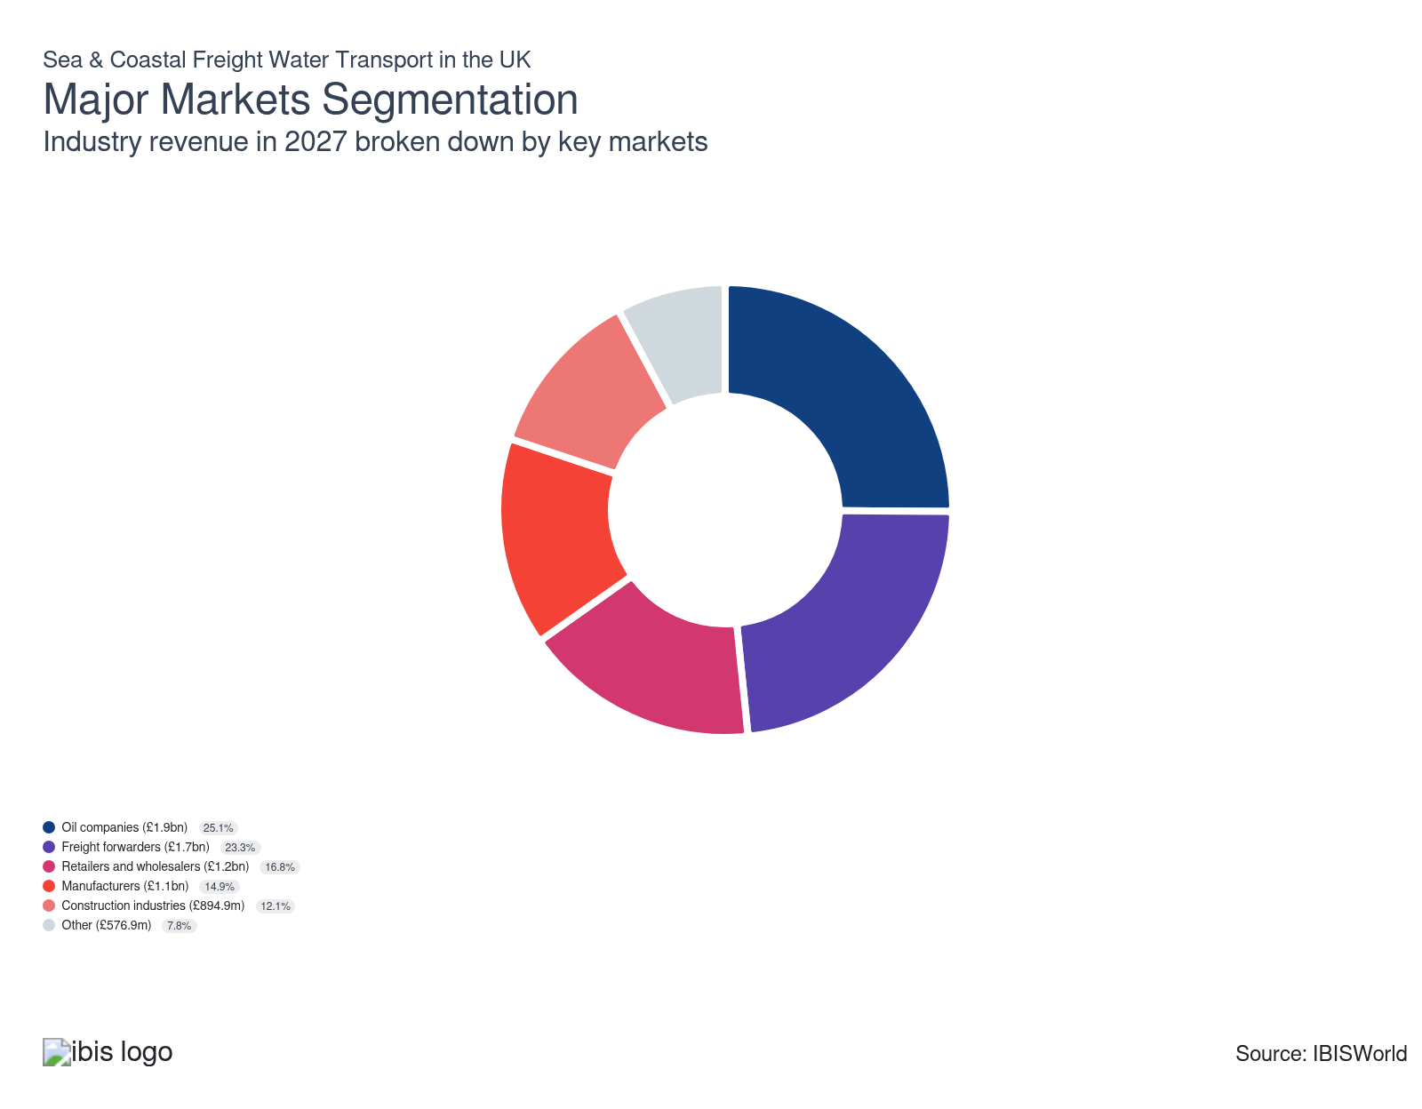

What’s influencing demand from the industry’s markets?

Oil companies continue to rely on transporting their products by water
- Oil companies use freight water transport to transport crude oil between offshore oil platforms and domestic ports, as well as importing and exporting it abroad.
- Global oil prices heavily influence demand from oil companies. When oil prices are high, shipping volumes typically increase, boosting revenue prospects. In 2026, the closure of the Strait of Hormuz pushed global oil prices sharply higher. According to the Financial Times, Brent crude prices rose by 57.7% in the years to 13 April 2026. This has raised the value of oil products shipped by sea, supporting revenue from this market.
- Mitigating the effect of higher prices, demand from oil companies remains low as the UK shifts to greener energy sources, like biomass. In October 2025, the Department for Energy Security and Net Zero forecast UK oil demand to fall by around 1.5% in 2026, reinforcing a downtrend in oil shipments even as price spikes support tanker revenue.

Freight forwarders see their activity climb due to growth in the number of SMEs
- Freight forwarders arrange freight transport on behalf of a third party; they act as intermediaries between freight water companies and end users. They purchase bulk space on ships and provide customers with access. Manufacturers and retailers are the biggest markets for freight forwarders.
- SMEs use forwarders to ship their products abroad, while most larger businesses handle their freight in-house. According to the Department for Business and Trade, the number of SMEs increased by 27% between 2010 and 2025, boosting demand from this market.
- Freight forwarders are contributing an increasing share of revenue thanks to the added benefits of integrated services that streamline client supply chains. These services are particularly advantageous amid more complex customs clearances post-Brexit and amid ongoing uncertainty regarding US tariffs in 2026.

Revenue from retailers and wholesalers fluctuates in line with economic conditions
- Retailers and wholesalers rely on freight water transport services to move large volumes of goods from manufacturers (both local and international) to retail centres.
- Water freight has become increasingly popular among large retail businesses seeking to improve their carbon footprint. By shifting goods in their supply chain to water, these businesses can significantly reduce emissions.
- The accelerating growth of e-commerce has driven up consumer purchasing volumes. Water freight enables more efficient, reliable transportation, which is vital for online stores to maintain inventory and meet demand. According to the Office for National Statistics (ONS), online sales accounted for 27.5% of all retail sales in February 2026, up from 25.9% in February 2025.
- Inflation remains a concern for retailers in 2025-26. CPI inflation reached 3% in February 2026, up from 2.8% in February 2025, according to the ONS. As income pressures persistently burden consumer budgets, demand for water freight services from retailers and wholesalers remains constrained.

Manufacturers' need for freight water transport activity remains constrained
- Manufacturers rely on freight water transport services to ship materials and finished goods.
- Manufacturers that bypass freight forwarders directly purchase water freight services to export goods, like automotive companies using short sea routes to ship cars.
- Manufacturers are increasingly opting for water freight to ship finished goods, as it’s a more sustainable option compared to air transport, helping to reduce their carbon footprint.
- Demand from manufacturers hinges on new orders and output, which align with economic conditions. The UK manufacturing PMI reached a 17-month high of 51.7 in February 2026, as reported by S&P Global. This output growth reflects stronger domestic demand and a softer decline in exports compared to previous months, putting manufacturing on a growth trajectory. However, output remains shaky as manufacturing struggles with high energy prices and a rising wage bill in the UK, which are restricting demand for water freight transport from the manufacturing sector.

Recovering construction output props up demand for freight water transport
- Freight water companies transport aggregates and construction products for businesses in the construction sector.
- In October 2025, the Construction Products Association forecast UK construction output to grow by 2.8% in 2026, driven by a rise in private housing construction. This comes after output began to recover in 2025. According to the ONS, total construction output grew by 1.8% in 2025.
- In a bid to keep costs down and reduce supply chain emissions, construction companies are increasingly sourcing aggregates from UK suppliers, reducing the need for international shipping. A 2025 Mineral Products Association report found that aggregate imports accounted for less than 5% of total supply in 2023, suggesting limited need for seaborne transport from the construction sector.

Other markets have little sway over the industry's performance
- Other markets include agricultural producers and the mining and minerals industries due to their need to transport large quantities of heavy cargo. These markets may transport cargo in containers when the speed of transport isn't too important.
- Other markets are increasingly using water freight transport to reduce their supply chain's carbon footprint.

International Trade

Some industries don't directly import or export goods. See reports at the manufacturing level for international trade data on relevant products.

5. Geographic Breakdown
https://my.ibisworld.com/uk/en/industry/H50.200/geographic-breakdown

Key Takeaways
- London's ports draw freight water companies in. The volume of traffic, alongside London's robust economy, provides ample business opportunities, causing freight water establishments to cluster in the capital.
- The South East's transport links attract freight companies. Major ports, like the ones in Southampton and Dover, offer extensive freight handling facilities and connections, making them perfect bases for freight water companies.

Business Locations
Region | Establishments (Units)  2026 | Establishments (%)  2026 | Establishments (YoY Growth %)  2026 | Population (%)  2026
South West | 26 | 3.9 | 2.6 | 8.5
South East | 81 | 12.3 | -0.8 | 14.0
Wales | 15 | 2.3 | 0.0 | 4.6
North West | 45 | 6.8 | 1.5 | 11.2
Northern Ireland | 10 | 1.5 | 0.0 | 2.7
Scotland | 66 | 10.1 | 0.0 | 7.8
East Midlands | 16 | 2.4 | 0.0 | 7.4
Yorkshire | 35 | 5.4 | -1.8 | 0.0
East of England | 83 | 12.6 | -0.8 | 0.0
London | 253 | 38.6 | 0.0 | 13.1
North East | 10 | 1.5 | 0.0 | 4.0
West Midlands | 17 | 2.6 | 8.3 | 8.9

Where are industry businesses located?

London is home to the most freight water companies
- The ports of London are important areas around which freight water companies are clustered. According to the Department for Transport (DfT), in 2024, London handled the most freight movement of all UK ports (12%), followed closely by Grimsby and Immingham.
- The city's strategic location near major European markets and its access to the River Thames make it a vital hub for both domestic and international shipping, attracting numerous shipping companies to the region. The growth of e-commerce has reinforced London's importance as a major port, with container volumes increasing significantly as goods are unloaded for onward distribution to UK online retailers and consumers.
- London’s strategic position as a global financial hub attracts significant trade and investment. Combined with its extensive maritime infrastructure, this makes it an ideal location for water freight companies.
- In terms of freight movement, the Port of London handled the highest freight traffic among all UK ports in 2025, almost 57 million tonnes, per the DfT. Furthermore, container shipping tonnage increased by 13% year-on-year in Q1 2025, primarily due to heightened maritime freight activity in the London area, according to the DfT. This surge was driven by the Port of London's launch of its fourth berth at London Gateway in November 2024, the world's first all-electric berth. This addition boosted the container port's trading capacity by over a third, significantly enhancing the region's shipping capabilities.

The South East's sizeable collection of ports attracts freight water companies
- The South East region’s strategic coastal location and proximity to key international shipping lanes make it a hotspot for freight water companies.
- Situated in the South East, the Port of Southampton is a vital cargo hub. It runs the UK's second-largest container terminal and handles £75 billion in exports annually, according to Freightos in 2024, linking the nation to major global trade routes. It also serves as a critical port for vehicle exports, used by leading automotive manufacturers to ship cars.
- The port of Dover (for ship-borne port-to-port trailers) is another significant port in the South East and has the largest roll-on/roll-off port in the UK. One of the major players, P&O Ferries, is headquartered in Dover, Kent and operates seven freight ferry routes, facilitating the transport of goods between the UK, Ireland and mainland Europe. The company primarily focuses on routes to France, Belgium, the Netherlands and Northern Ireland.
- The Thames Freeport in London, bordering the South East, offers major financial advantages that attract maritime companies. Companies benefit from simplified customs procedures, tax reliefs and government support for innovation, which creates a competitive edge for importers, exporters and manufacturers.
- The region benefits from its strong connectivity to other major trade centres. It features efficient road access via the M3 and M27, as well as robust rail links, all of which enhance the transportation of goods.

Companies flock to the Port of Felixstowe in the East of England
- The East of England's significant number of establishments is largely attributable to the Port of Felixstowe, the country's largest container-handling port. Felixstowe manages the highest volume of containerised traffic in the UK, accommodating around 2,000 ships annually, according to the BBC in 2024.
- The region also hosts Port Harwich, an international gateway to Europe, providing 25 weekly roll-on/roll-off (Ro-Ro) freight connections to the Netherlands. Together with Felixstowe, Harwich forms Freeport East, established through a £25 million government funding initiative in 2023. As a special economic zone, it allows goods to be traded with reduced customs duties and regulations, attracting shipping companies to the area.
- The Port of Harwich and Felixstowe benefit from proximity to the River Orwell and connections to the River Stour, offering potential for inland waterway freight movements to reduce reliance on road transport. The region's waterway infrastructure supports emerging opportunities for barging and short-sea shipping to distribute goods inland, particularly for lower-cost, lower-carbon freight movements.
- The region's strategic connectivity to major international shipping routes enhances its appeal for freight operations. Its prime coastal location along the North Sea offers direct access to European and global trade routes, making it a crucial area for freight water companies.
- The East of England boasts extensive transport infrastructure, including excellent road connections such as the A14 and A12, as well as strong rail links, all of which facilitate efficient movement of goods to and from ports.


How do businesses use location to their advantage?
Establish overseas networks for developing export markets and sourcing imports
Building robust networks with international markets allows freight water companies to efficiently manage their import and export operations. These networks enhance market reach and diversify revenue streams, making operations smoother and more profitable.
Operate in a location that is close to transport
Freight water companies must be situated near key transport networks, like major motorways and rail terminals, to facilitate the efficient movement of goods to and from the port.

6. Competitive Forces
https://my.ibisworld.com/uk/en/industry/H50.200/competitive-forces

Key Takeaways
- Pricing determines freight water companies’ competitiveness. Market overcapacity means companies vie fiercely for customers, trying to draw them in with lower rates.
- Other transport methods pose huge competitive threats. The convenience, efficiency and lower prices of road and rail freight make them popular alternatives for both domestic and international goods transportation.

Concentration
Low
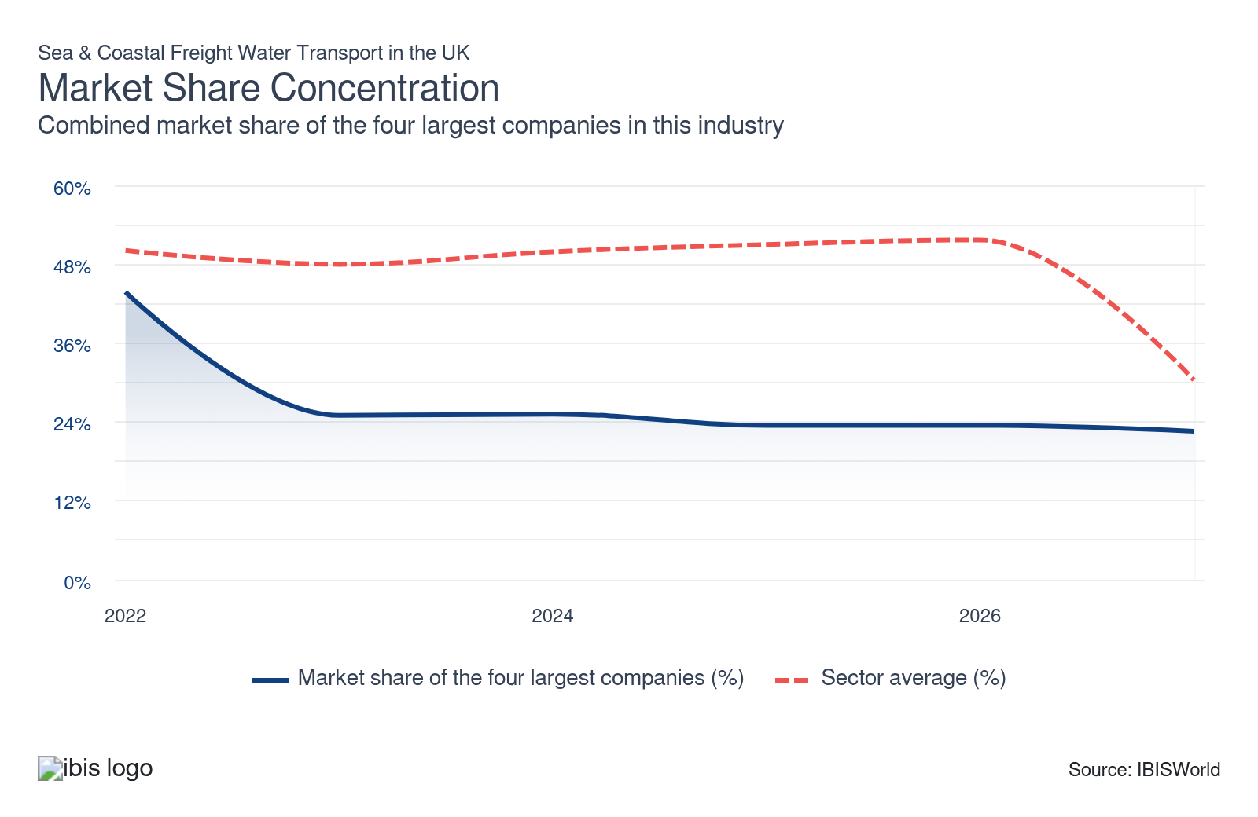

What impacts the industry’s market share concentration?

Concentration varies depending on shipping markets, routes and product categories
- Deep-sea shipping often has higher barriers to entry due to the types of vessels required to operate over long distances, so companies offering this service often operate in a concentrated market.
- Companies face substantial regulatory barriers before they can transport dangerous or hazardous products. As a result, concentration tends to be higher in these segments.
- Some international shipping companies have adjusted their routes to capitalise on changing trade patterns. Global supply chain disruptions, like the Red Sea crisis, have also forced ships to reroute, adding operational costs that can hinder growth, especially for smaller businesses.
- As fuel sources and volumes have changed, so have the market shares of the leading shipping companies linked to global energy companies. For instance, BP Shipping Ltd’s market share has expanded amid elevated fuel prices in recent years.

Challenging economic conditions drive down concentration
- Larger ships reduce the average cost per tonne of freight, allowing larger companies to undercut smaller competitors on price while still maintaining profitability, making mergers and acquisitions appealing. Vertical integration can also help reduce unit cost. For example, CMA CGM completed its acquisition of Freightliner UK in 2025, integrating rail and road capabilities to expand its intermodal offering.
- Even large shipping companies are grappling with logistical bottlenecks caused by widespread supply chain disruptions, which have led to reduced trade volumes and negatively affected their revenue growth.
- In 2022-23, concentration dropped sharply, as Evergreen Marine's revenue plummeted by 72% in 2022 due to challenging economic conditions affecting operations and cargo lifting volumes. These challenging conditions have seen the market share of the largest UK companies contract as opportunities for smaller companies open up.

High barriers to scale hold concentration down
- Limited access to major ports and the significant capital investment needed to expand operations create high barriers to entry in the Sea and Coastal Freight Water Transport industry. These constraints prevent any single shipping company from dominating the market.
- Regional and market demand variations encourage freight water transport companies to specialise in specific markets or focus on certain products and services. This specialisation prevents any one company from gaining significant control over the market. For instance, BP Shipping is dedicated to transporting oil and gas globally, while P&O specialises in Roll-on/Roll-off cargo between the UK and mainland Europe.

How do successful businesses handle concentration?
Optimise operating capacity
In the face of squeezed profitability, it’s increasingly important for shipping companies to optimise capacity utilisation to keep operating costs low. This allows them to charge lower prices, which helps to draw in custom.
Integrate operations
Integrated operations streamline processes and enhance operational efficiencies, enabling companies to offer better rates and services. This helps attract more clients and securing a larger market share.

Barriers to Entry
High | Steady

What challenges do potential industry entrants face?

Legal
- Regulation is heavy due to the environmental and health risks associated with the industry. Freight water companies must comply with regulations developed at the global level, with the industry's international nature making the implementation of uniform regulations important. Also, Brexit-related customs complexities have heightened compliance burdens.

Start-Up Costs
- The primary barrier to entering the industry is the high cost of acquiring suitable vessels. As container ships grow larger and incorporate more advanced, environmentally friendly technologies, their costs continue to climb. Additionally, port fees and insurance expenses further contribute to the financial burden.

Differentiation
- To stand out from the crowd, new entrants can specialise in more niche goods and services or provide consumers with advanced and environmentally sustainable fleets. A new freight shipping company would also need to offer more competitive rates, which may not be sustainable for the company.

Capital Expenses
- The industry is characterised by high capital intensity, driven by the costs of purchasing or leasing capital-intensive ships, port infrastructure fees and specialised cargo-handling equipment. Capital intensity is inching up as major shipping companies invest in larger vessels to expand capacity.

How can potential entrants overcome barriers to entry?
Accommodate environmental requirements
Companies are expected to ensure that their vessels meet the proper environmental standards. Compliance with environmental requirements also attracts eco-conscious clients and partners.
Comply with government regulations
Vessels and tankers need to comply with rigid engineering and safety standards to be allowed to operate. This compliance also builds credibility and trust with customers and stakeholders, ensuring success in the industry.

Substitutes
Moderate | Steady

What are substitutes for industry services?

Freight Air Transport
- Air freight offers an alternative to water freight for international transport. It provides a quicker and more reliable method of transportation, although it comes at a higher cost.
- Air freight ensures shipments can reach global destinations within hours or days, compared to weeks required for maritime transport. This efficiency is crucial for perishable items and emergency deliveries.
- Sea freight offers a significantly lower carbon footprint compared to air freight. According to the Climate Action Accelerator, as of June 2024, sea freight emits 68 times less carbon dioxide than air transport. This environmental advantage has become increasingly important as companies strive to minimise their environmental impact.

Freight Road Transport
- Road freight can be used as a substitute for water freight transport for moving non-bulk freight, with the choice between the two typically depending on distance, cost and environmental considerations.
- Road transport provides door-to-door service, making it highly efficient for inland destinations without waterways.
- Customers often use road freight as a last resort unless they're only moving goods within the UK. Road freight faces challenges such as traffic congestion, higher fuel costs and greater carbon emissions, rendering it a less favourable substitute.

Freight Rail Transport
- Improvements to the UK's rail system, primarily in its size and environmental impact, have raised the usage of rail freight over other freight substitutes.
- Rail freight offers customers a suitable balance between cost efficiency, environmental impact and speed. In 2023, the UK government announced a target to increase rail freight by at least 75% by 2050. Initiatives like the Mode Shift Revenue Support grants and substantial infrastructure investments support this goal, emphasising the reduced environmental impact of rail transport.
- Rail freight’s level of competition as a substitute is limited, as it does not enable goods to be transported overseas, except by lorries through the Channel Tunnel. In February 2026, the UK government backed a £15 million investment in the Barking Eurohub to restart regular intermodal cross-Channel rail freight, which could open a direct rail route between the UK and mainland Europe in the near future.

How do successful businesses compete with substitutes?
Maintain excellent customer relations
Strong relationships with customers can lead to repeat business and positive word-of-mouth referrals. Good referrals can differentiate your services from substitutes, ensuring repeat business.
Provide superior after-sales service
Providing excellent after-sales support enhances client satisfaction and fosters customer loyalty. This added value makes the service more attractive compared to other transport methods.

Buyer & Supplier Power
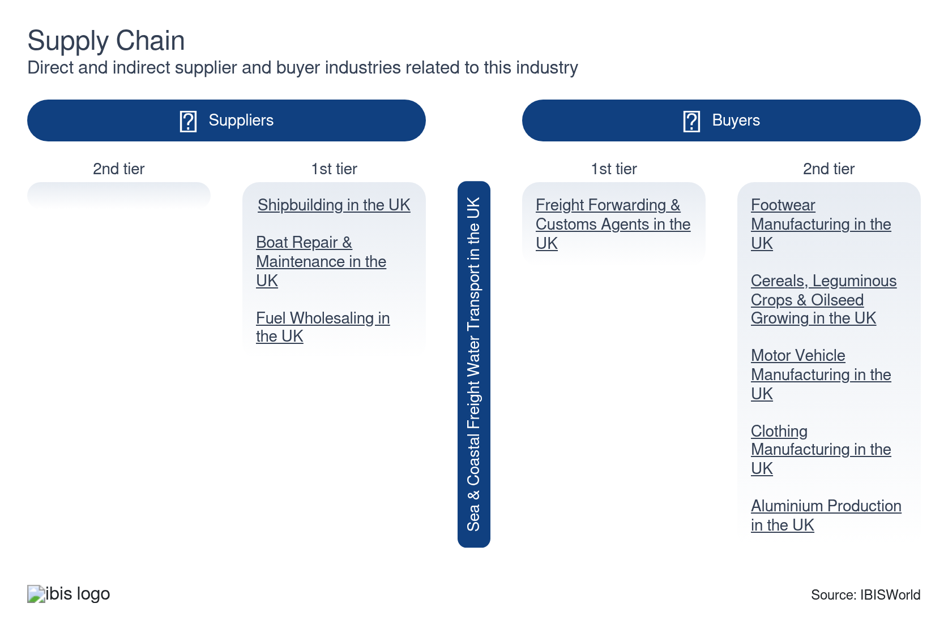

What power do buyers and suppliers have over the industry?

Buyers: Price and routes offered prove pivotal
Low | Steady
- Buyers typically select sea and coastal freight water transport companies based on price, the variety of shipment options and the efficiency of freight routes offered.
- Buyer power is low, as buyers are largely price takers. Freight water transport businesses are able to pass rising fuel costs on to customers, particularly in recent years when global supply chain issues have inflated fuel prices. Buyer power is further limited as these cost increases are applied across the industry, meaning switching providers would not result in lower prices.
- The only real alternative to freight water transport for international shipments is air transport, which is more expensive. Buyers who are looking for low prices, therefore, have little choice but to pay the prices freight water companies set.

Suppliers: Major fuel companies and shipbuilders hold significant leverage
Moderate | Steady
- The global bunker fuel market is highly concentrated, dominated by a handful of oil majors like BP, Shell, ExxonMobil and Chevron, which exert significant power thanks to their control of downstream operations. Shipping companies are effectively price-takers, as bunker prices are tied to global crude benchmarks like Brent.
- Major suppliers can introduce surcharges or restrict supply during periods of tight availability. This dynamic is evident in 2026-27, after Brent crude rose to its highest level since June 2022, passing US$115 (£85.50) in March 2026, according to Trading Economics, prompting a surge in shipping costs for companies.
- The shipbuilding market is highly concentrated. Xclusiv Shipbrokers data indicate that the yards actively taking newbuilding orders rose only from 153 in June 2022 to 180 by June 2024, keeping building capacity tight. This constrained capacity and long order books grant shipbuilders substantial pricing power, enabling them to charge higher prices and insist on less flexible delivery and contract terms for shipping companies.

How do successful businesses manage buyer & supplier power?
Pass on cost increases
Fuel costs have been extremely volatile and companies need to be able to pass higher operating costs on to their customers when necessary in order to remain profitable.
Develop a loyal customer base
Timely delivery is important when it comes to shipping, so companies must have processes in place to ensure they operate efficiently to maintain a good reputation and retain customers for repeat business.

7. Companies
https://my.ibisworld.com/uk/en/industry/H50.200/companies

Key Takeaways
- Evergreen’s loses its market dominance. Evergreen’s market share fell sharply over the past five years and its earnings have been highly volatile, as aggressive fleet expansion by larger competitors and intense price competition have squeezed its position.
- BP Shipping plays a crucial role in the BP group’s operations. It manages around 6,000 worldwide voyages per year, transporting vital crude oil, liquefied natural gas and liquefied petroleum gas.

Market Share
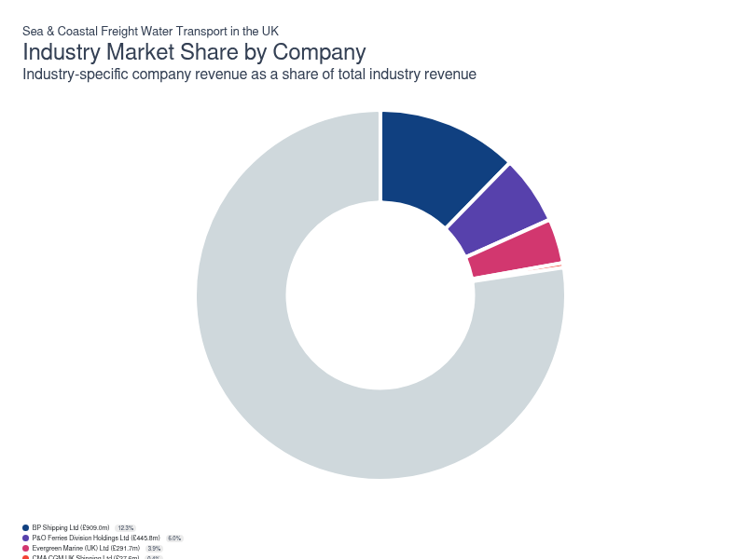
Chart displays current year only in the PDF version of this report. You can view and download chart for all other years associated with this industry on my.ibisworld.com.

Companies
Company | Market Share (%)  2027 | Revenue (£m)  2027
BP Shipping Ltd | 12.3 | 909.0
P&O Ferries Division Holdings Ltd | 6.0 | 445.8
Evergreen Marine (UK) Ltd | 3.9 | 291.7
CMA CGM UK Shipping Ltd | 0.4 | 27.6

BP Shipping Ltd
BP Shipping Ltd
Company Details
Company Details
Industry Specific Revenue (2027) | £909.0m
Market Share (2027) | 12.3%

Description
Description
BP Shipping Ltd, headquartered in Sunbury On Thames, Middlesex, is the shipping arm of oil and gas giant BP plc. The [parent company is involved in upstream and downstream energy operations, including oil and gas exploration, production, refining and distribution. It’s a leading UK producer of hydrocarbons and its extraction business is based in Aberdeen, Scotland. In support of its oil and gas operations, BP plc launched its own shipping fleet in 1915.

Company’s Industry Revenue, Market Share, and Profit Margin Over Time
Company’s Industry Revenue, Market Share, and Profit Margin Over Time
Year | Industry Revenue ($ million) | Market Share (%)
2019-20 | 407 | 7.0
2020-21 | 503 | 9.3
2021-22 | 475 | 8.5
2022-23 | 701 | 11.1
2023-24 | 832 | 12.6
2024-25 | 850 | 12.4
2025-26 | 895 | 12.7
2026-27 | 909 | 12.3

What's impacting BP Shipping Ltd's performance?

BP Shipping operates within the wider BP oil and gas group
- Efficiency is paramount because BP Shipping acts as a strategic performance unit of the BP Group. BP Shipping completes around 6,000 voyages per year, with its vessels transporting crude oil, liquefied natural gas and liquefied petroleum gas worldwide.
- As of December 2024, BP Shipping’s fleet included 48 vessels, up from 46 in 2022. The fleet comprises 24 BP-operated ships, 22 time-chartered vessels and two supply vessels, handling international oil and liquefied natural gas.
- To stay ahead of the competition, the company regularly upgrades its ships with cutting-edge technologies. These include advanced hull coatings that improve anti-fouling properties and the Mewis Duct, an energy-efficient device that can reduce fuel consumption and emissions by up to 7%. This commitment to efficiency enhances the company's revenue prospects.

BP envisions a green future with low-carbon solutions
- BP is expanding its use of biofuels sourced from sustainable materials like cooking oil and waste oils from sewage systems. In collaboration with its lubricants business, Castrol, BP is increasingly using biofuels for its vessels and supplying them to third parties via Castrol’s distribution network.
- In August 2022, BP initiated trials of new technologies and fuels to reduce carbon emissions in its shipping sector. These include air bubble lubrication systems, which reduce propulsion energy by lowering resistance between ships and seawater, potentially cutting emissions by 4% to 6%.
- The company continues to invest in bioenergy, partnering with WasteFuel in July 2023 and investing US$10 million (£8.1 million) in developing a global network. This investment helps BP decarbonise operations while potentially saving costs by reducing its reliance on volatile oil prices.
- In 2024, the liquefied natural gas vessels British Listener and British Mentor were upgraded with air lubrication systems. These systems minimise friction, leading to reduced fuel consumption and lower carbon emissions. This advancement enhances the vessels’ energy efficiency, environmental impact and brand image.

Higher freight rates support revenue growth
- Compared to the broader industry, BP Shipping performed exceptionally well in 2023, particularly in the face of operational constraints. Its revenue surged by 16.2%, driven by higher freight rates, which resulted from supply chain disruptions limiting capacity amid heightened demand. Growth in turnover outpaced the rise in cost of sales because bunker prices rose less than freight rates, resulting in strong profit growth.
- Despite weaker demand in 2024, the company maintained solid revenue growth. Although voyages dropped by 4% and cargo tonnage by 8%, the company offset rising operating costs created by geopolitical instability by raising freight rates, protecting revenue and profit.
- From February 2026, the outbreak of conflict between the US and Iran has effectively closed the Strait of Hormuz to tanker traffic, significantly disrupting global oil supply routes. The resulting climb in oil prices has created a dual shock for BP. Operating costs have risen as the price of bunker fuel for BP’s ships has grown dearer. However, strong oil prices enable BP to expand freight rates on its oil shipments to pass on these higher costs and preserve profit
P&O Ferries Division Holdings Ltd
P&O Ferries Division Holdings Ltd
Company Details
Company Details
Industry Specific Revenue (2027) | £445.8m
Market Share (2027) | 6.0%

Description
Description
P&O Ferries Division Holdings Ltd is a subsidiary of DP World, one of the world's largest sea cargo terminal operators. P&O was originally established in England in the 19th century. It's been a subsidiary of Dubai-based DP World since 2019, which re-acquired it for approximately £322 million, having previously owned it in 2006. It operates a fleet of vessels providing passenger and freight services between the UK and countries across the English Channel, the North Sea and the Irish Sea. P&O is headquartered in Dover, Kent.

Other Industries
Other Industries
- Sea & Coastal Passenger Water Transport in the UK

Company’s Industry Revenue, Market Share, and Profit Margin Over Time
Company’s Industry Revenue, Market Share, and Profit Margin Over Time
Year | Industry Revenue ($ million) | Market Share (%)
2019-20 | 370 | 6.3
2020-21 | 361 | 6.7
2021-22 | 365 | 6.5
2022-23 | 408 | 6.5
2023-24 | 388 | 5.9
2024-25 | 424 | 6.2
2025-26 | 437 | 6.2
2026-27 | 446 | 6.0

What's impacting P&O Ferries Division Holdings Ltd's performance?

P&O boasts an expanding distribution network
- P&O operates over 300 departures per week using 14 vessels, serving more than 2,000 businesses through P&O Freight.
- P&O's shipping services range from livestock transport to the shipment of hazardous materials. Its extensive distribution network connects France, Belgium, Northern Ireland, Scotland, the Netherlands and England.
- In July 2023, P&O confirmed its long-term commitment to North Sea routes by extending its charter agreement with Bore Ltd for two ro-ro freight vessels, aiming to enhance trade flow between Belgium and the UK.
- In March 2024, P&O launched a new Tilbury to Europoort RoPax service, enhancing its presence on the North Sea. Despite past operational challenges, the company continues to invest in its operations and increased capacity on the popular London-to-Rotterdam freight route in March 2025 with a second vessel.

P&O continues to battle with operational challenges
- In 2022, the company temporarily halted several routes due to workforce restructuring in March, which significantly reduced freight volumes and revenue. Amid the ensuing controversy over redundancies, P&O incurred substantial restructuring costs.
- In 2022 and 2023, P&O encountered ongoing challenges due to inflationary pressures that affected both demand and operating costs. In response, the company reviewed its routes and restructured its network in 2023, resulting in the closure of the Teesport-Europoort and Liverpool-Dublin routes.
- The company's freight market contracted by approximately 5% in 2023. To mitigate costs, the group focused on optimising its strategy by better targeting sailings and reducing the number of trips outside peak hours.

A redundancy scandal sullies the company’s image
- In March 2022, P&O Ferries laid off 786 seafarers to implement a more flexible staffing model aimed at reducing costs and achieving profitability, following several years of operating at a loss. This mass redundancy led to significant public backlash, tarnishing the company’s reputation.
- The mass redundancy left a lasting legacy on the company, as well as the wider industry, with the government stepping in to boost seafarers’ rights at work. The government introduced the Employment Rights Bill in October 2024, which enforces stricter rules on dismissals, protects wages and increases penalties for non-compliance. These changes aim to close wage loopholes and improve working conditions, raising expenses for non-compliant companies like P&O.
- In November 2024, P&O Ferries had received more than £400 million in loans since the controversy from its parent company, DP World, to mitigate financial losses. P&O maintains that its contentious restructuring was essential for achieving a sustainable future through a more flexible operating model.
Evergreen Marine (UK) Ltd
Evergreen Marine (UK) Ltd
Company Details
Company Details
Industry Specific Revenue (2027) | £291.7m
Market Share (2027) | 3.9%

Description
Description
Previously known as Hatsu Marine Ltd, Evergreen Marine (UK) Ltd is a subsidiary of the Taiwanese Evergreen Group, a global containerised freight shipping company that operates out of 240 ports in 80 countries. Evergreen has grown and diversified since it was established in 2002 and now transports goods by land, sea and air. The company operates out of London as a UK-flag container shipping company under the brand name Evergreen Line.

Company’s Industry Revenue, Market Share, and Profit Margin Over Time
Company’s Industry Revenue, Market Share, and Profit Margin Over Time
Year | Industry Revenue ($ million) | Market Share (%)
2019-20 | 1359 | 23.3
2020-21 | 1418 | 26.2
2021-22 | 1586 | 28.4
2022-23 | 444 | 7.0
2023-24 | 420 | 6.3
2024-25 | 311 | 4.5
2025-26 | 294 | 4.2
2026-27 | 292 | 3.9

What's impacting Evergreen Marine (UK) Ltd's performance?

Being part of a wider global group gives Evergreen Marine recognition
- The Evergreen Line is the common trade name of the five shipping companies that comprise the Evergreen Group. These are Evergreen Marine (UK) Ltd, Evergreen Marine Corp (Taiwan) Ltd, Italia Marittima SpA, Evergreen Marine (Hong Kong) Ltd and Evergreen Marine (Singapore) Pte Ltd. With such a vast global presence, the company benefits from diversified markets and income opportunities.
- The Evergreen Line fleet is one of the five largest container fleets in the world, incorporating 214 vessels with a total capacity of just under 1.7 million twenty-foot-equivalent units (TEUs) as of 2023.
- The company’s UK service network moved a total volume of 389,261 TEUs in 2023 and is expecting delivery of new ships, increasing its global capacity by 550,000 TEUs in 2027.

The company's global reach allows it to benefit from greater scale
- Evergreen is a member of the Ocean Alliance, a consortium of four of the world's leading container carriers. In February 2024, Evergreen extended its partnership with the Ocean Alliance for five more years, ensuring continued high-quality shipping services until March 2032.
- In March 2024, the Ocean Alliance launched The Day 8 Product, providing an improved and optimised global network, especially in Asia. This initiative improves service with broader port coverage, faster transit times and greater reliability, addressing supply chain disruption challenges in the Red Sea.
- In November 2024, PSA Singapore and Evergreen established a joint venture in Singapore, which is set to boost operational efficiency and achieve greater synergies in global container operations.

Revenue plummets as Evergreen faces challenging operating conditions
- In 2022, Evergreen's revenue plunged by 72% due to unfavourable economic conditions and global supply chain disruptions. Operational disruptions in Euro-Mediterranean trade and the China-Europe Shuttle service facing severe delays due to port congestion hit the company’s performance. Despite a decline in cargo lifting, profit stayed positive thanks to higher ocean freight rates.
- Persistent supply chain disruptions were exacerbated by geopolitical issues, weighing on international trade. In 2023 and 2024, declining freight rates and increased sea capacity due to oversupply caused a continued revenue downturn, including a drop of 25.9% in 2024.
- Evergreen has hugely underperformed the wider industry in recent years, significantly reducing its market share. To mitigate these income fluctuations, the company is intensifying its focus on expanding revenue from vessel chartering, including the renewal and extension of several time-charter and slot-charter arrangements with major liner operators in 2024, which is expected to underpin more stable charter income and support revenue growth.
CMA CGM UK Shipping Ltd
CMA CGM UK Shipping Ltd
Company Details
Company Details
Industry Specific Revenue (2027) | £27.6m
Market Share (2027) | 0.4%

Description
Description
CMA CGM Group is an international shipping company headquartered in France. Established in the mid-19th century, the group now operates in over 160 countries. The company also provides port handling facilities, logistics support and inland transport options, including dedicated rail services. Its UK arm, CMA CGM UK Shipping Ltd, was established in 1990 and is headquartered in Liverpool.

Company’s Industry Revenue, Market Share, and Profit Margin Over Time
Company’s Industry Revenue, Market Share, and Profit Margin Over Time
Year | Industry Revenue ($ million) | Market Share (%)
2019-20 | 18 | 0.3
2020-21 | 18 | 0.3
2021-22 | 22 | 0.4
2022-23 | 23 | 0.4
2023-24 | 23 | 0.4
2024-25 | 26 | 0.4
2025-26 | 27 | 0.4
2026-27 | 28 | 0.4

What's impacting CMA CGM UK Shipping Ltd's performance?

CMA CGM positions for UK intermodal expansion
- In September 2025, CMA CGM announced its acquisition of Freightliner UK Intermodal Logistics, a key player in Britain’s rail-linked container transport sector with the deal completing on 29 January 2026. This move will add 10 inland terminals and over 80 daily rail services, covering more than 770,000 containers annually.
- The integration of Freightliner’s network is set to increase CMA CGM’s UK intermodal market share, providing seamless door-to-door logistics and enhancing connectivity from major ports such as Felixstowe, Southampton and London Gateway.
- This acquisition supports CMA CGM’s decarbonisation strategy by making it easier for shippers to shift freight from road to rail, in line with wider industry trends towards low-carbon transport solutions. Once completed, the deal is likely to boost demand for CMA CGM’s core sea and coastal freight routes as integrated logistics become a stronger customer offering.

You can view and download company details on my.ibisworld.com.

8. External Environment
https://my.ibisworld.com/uk/en/industry/H50.200/external-environment

Key Takeaways
- MARPOL curbs emissions from freight water companies. It outlines stringent rules focusing on the reduction of sulphur oxides and nitrous oxides released from ships.
- The International Maritime Organisation standardises maritime safety regulations. Through its International Convention for the Safety of Life at Sea, it sets universally adopted rules for shipping companies to secure safety and fairness within the industry.

External Drivers

What demographic and macroeconomic factors impact the industry?
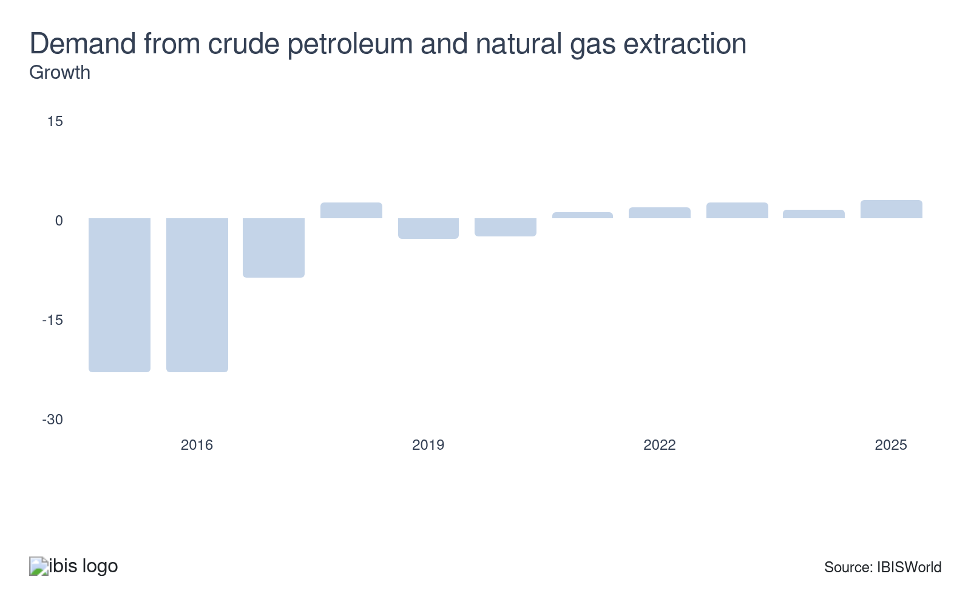
Crude oil and oil products account for a big chunk of all the freight that passes through major UK ports, meaning freight water companies are heavily dependent on demand from oil companies. As oil and gas extraction expands, so does the need to transport these resources, boosting freight volumes and stimulating revenue growth. Conversely, a decline in extraction reduces freight water transport demand.
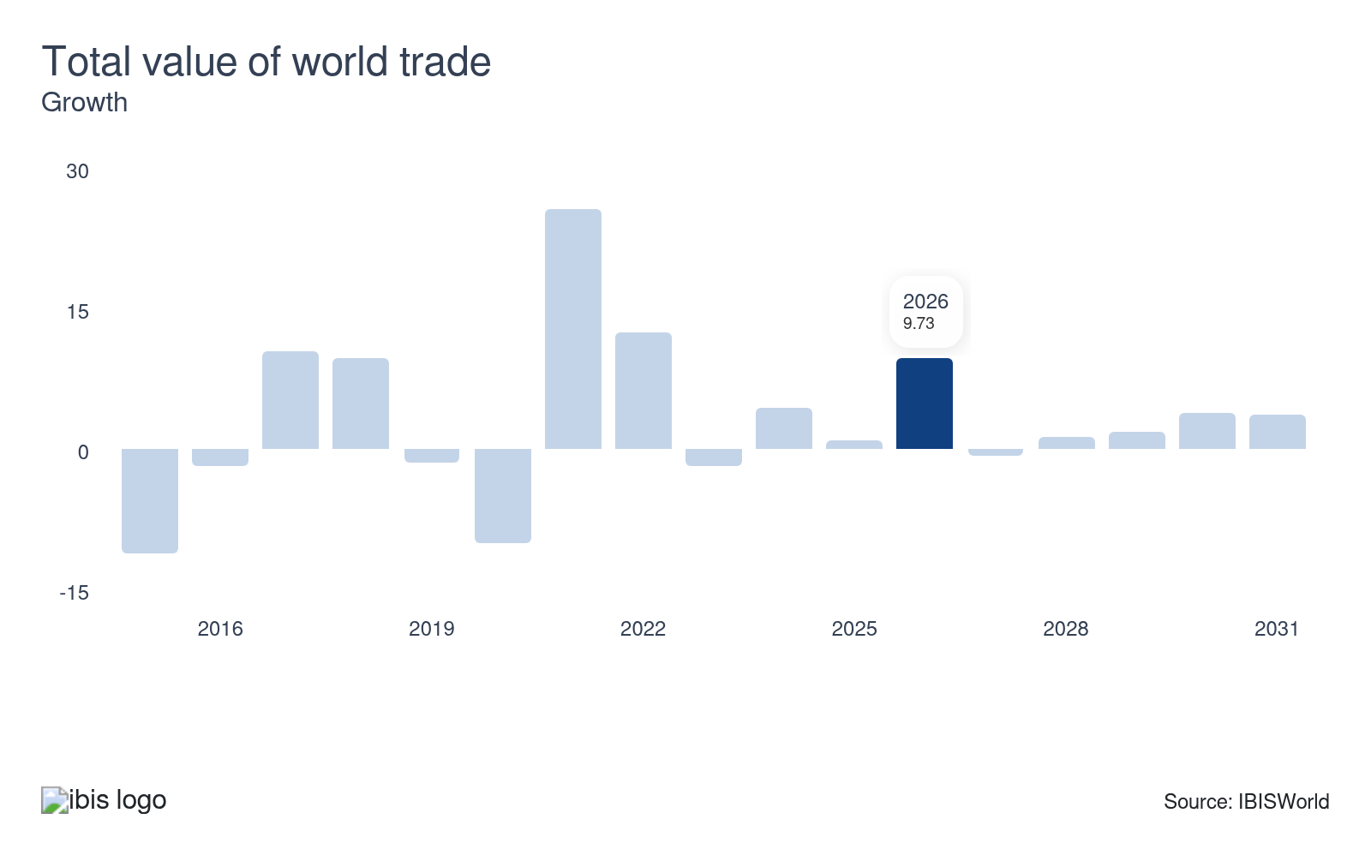
A lot of water freight transport involves the movement of goods internationally, which means companies are likely to benefit from increased world trade – this means a greater need for shipping services. As global trade expands, the demand for maritime transport escalates, driving freight volumes and presenting income opportunities for the industry.
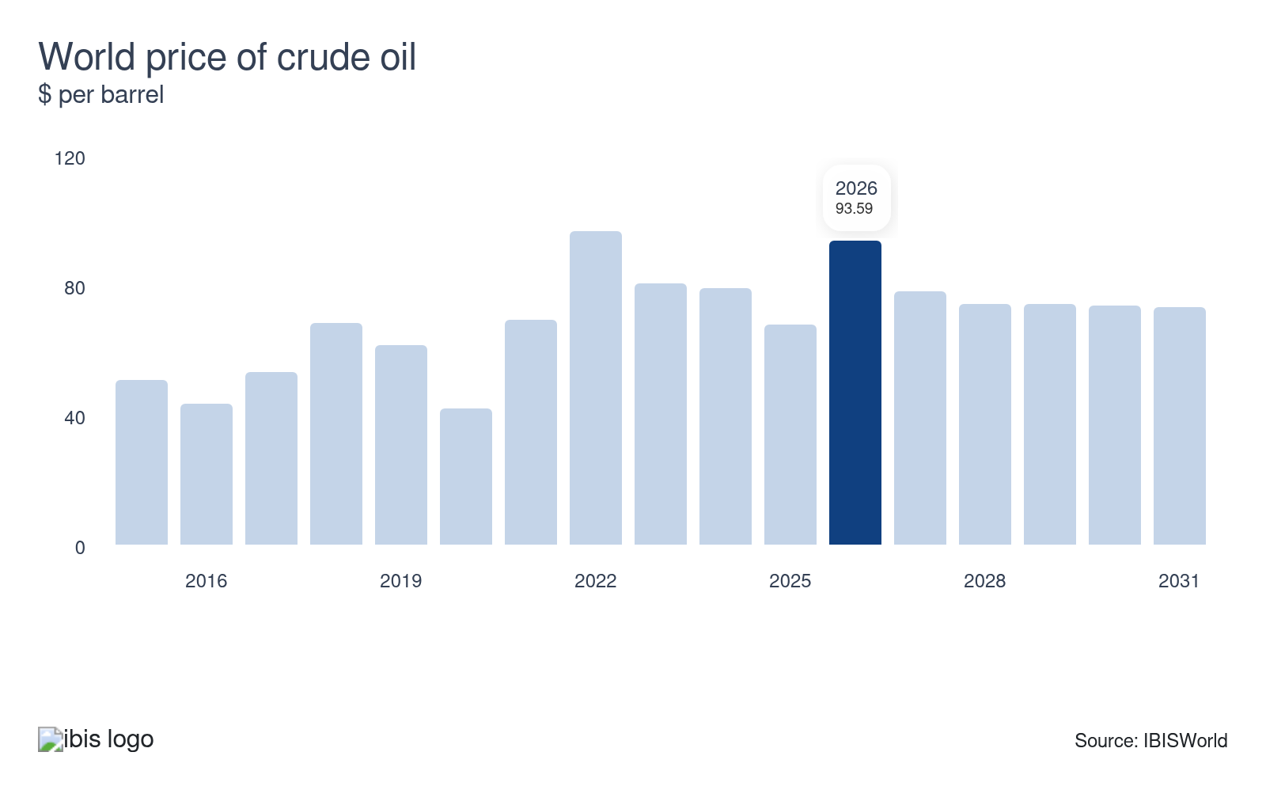
Fuel is a major component of freight water businesses’ cost structures. Any increase in the price of fuel raises operating costs and eats into profitability, though companies may be able to pass on these cost increases depending on the sensitivity of demand to price changes. Falling oil prices reduce costs and support profitability. Mounting fuel prices prompt maritime freight companies to increase freight rates, which influences demand and revenue levels.
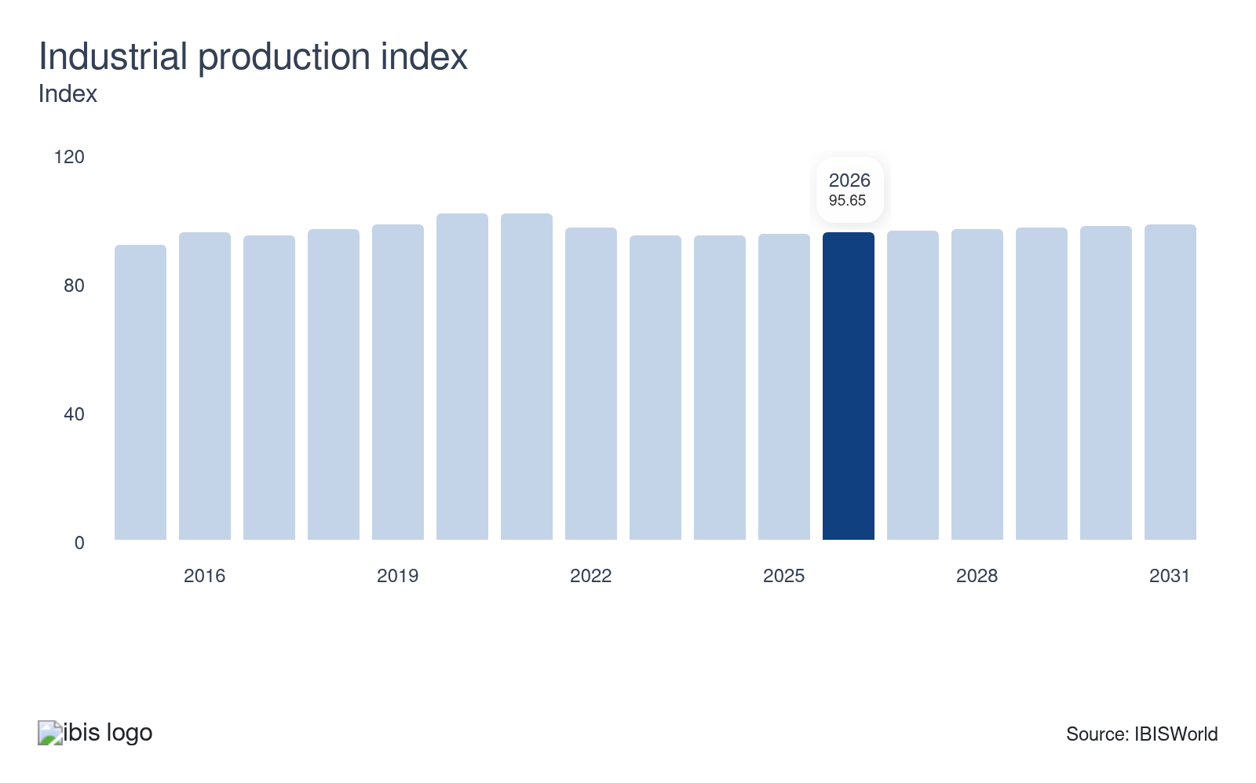
The industrial production index can be used as a proxy for demand for the finished goods of production industries. Sea and coastal freight water services play a crucial role in global supply chains by transporting raw materials from ports to factories. When industrial output rises, the need for the transportation of goods, materials and commodities expands, resulting in greater demand for freight water transport operations.
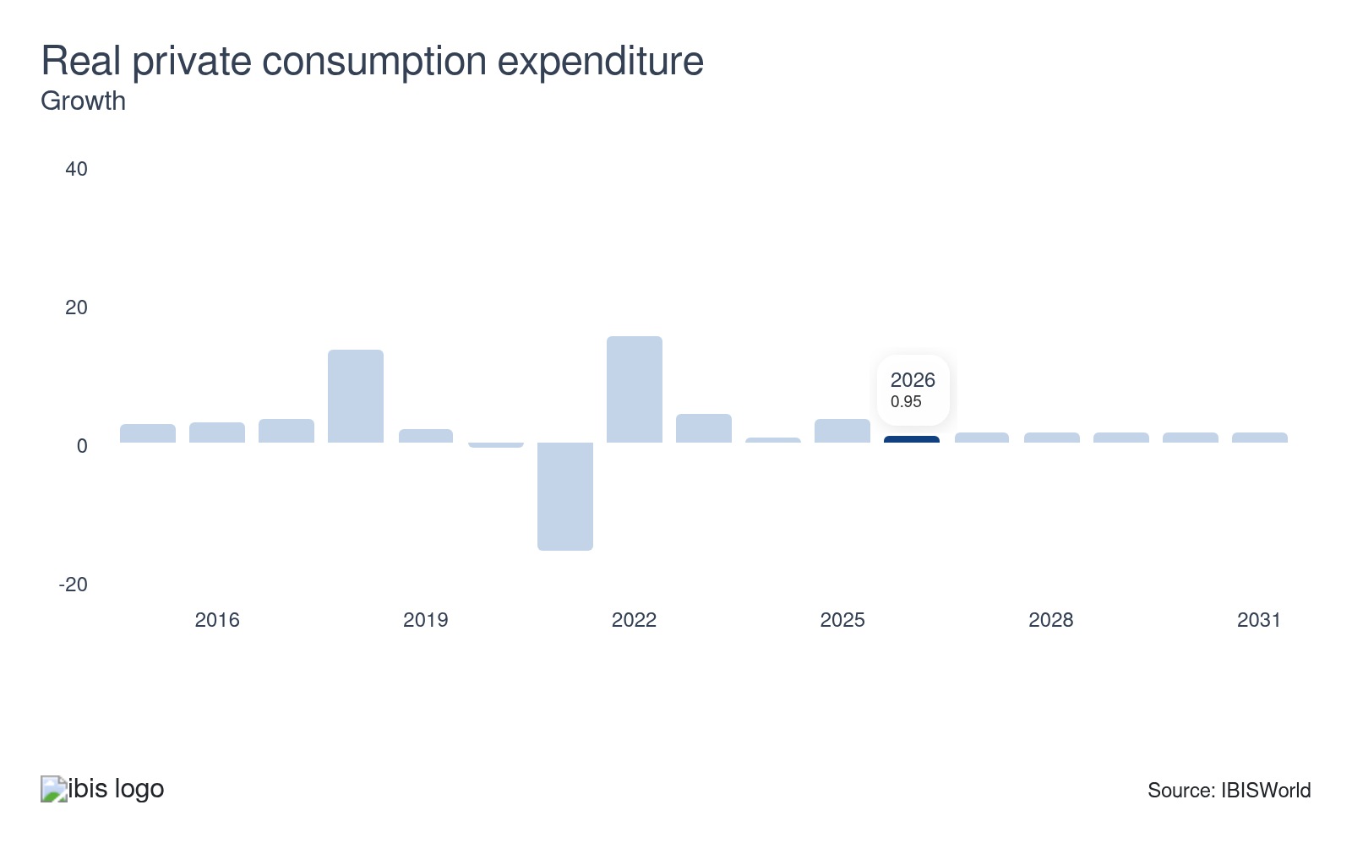
Private consumption expenditure levels drive demand for freight water transport, as sea and coastal freight services are essential components of the global supply chain. When consumer spending rises, this boosts imports and exports, expanding freight volumes. However, when consumer spending dips, demand for water freight transport also declines, posing a threat to the industry’s revenue prospects.

Regulation & Policy
High | Increasing

What regulations impact the industry?

International Maritime Organisation (IMO)
The industry is subject to maritime safety and security regulations established by the IMO, a specialised agency of the United Nations. The IMO's main role is to create a regulatory framework for the shipping industry that’s fair, effective and universally adopted. Its main requirements are mandated through the International Convention for the Safety of Life at Sea. IMO regulations include the Safety of Life at Sea (SOLAS) convention, which ensures vessels meet essential safety standards; Marine Pollution (MARPOL), which regulates emissions and waste disposal; and Standards of Training, Certification and Watchkeeping (STCW), requirements for seafarer qualification. In January 2025, new regulations were implemented to improve safety and environmental protection, including specific guidelines for the safe transport of lithium batteries, addressing rising safety and environmental concerns.

Maritime and Coastguard Agency (MCA)
The MCA is responsible for implementing the government's maritime safety policy in the UK on behalf of the Department for Transport. It issues Marine notices, some of which are mandatory. These inform the shipping and fishing industries of important safety, pollution prevention and other maritime information. The MCA also conducts inspections, certifications and safety audits and responds to maritime emergencies. In October 2024, the MCA introduced a new online tool designed to help seafarers more easily locate approved service stations for life-saving appliances. This tool includes enhanced filtering capabilities, contributing to improved safety measures within the industry.

Annex VI to the International Convention for the prevention of Pollution from ships (MARPOL Convention)
Regulations governing airborne emissions from ships are included in Annex VI to the MARPOL Convention, which mandates the use of cleaner fuels and emission control technologies. The framework controls sulphur oxides and nitrogen oxides through designated Sulphur Emission Control Areas (SECAs), where fuel sulphur content limits are stricter. Currently, there are five SECAs worldwide: the Baltic Sea, North Sea, US East Coast, US Caribbean ECA and the English Channel SECA. The global sulphur cap (0.5% mass by mass) has been in effect for all vessels since January 2020, replacing the previous limit of 3.5%. Compliance is becoming increasingly complex as the UK Emissions Trading Scheme extends to domestic maritime from 2026, layering carbon pricing on top of existing fuel and technology requirements, tightening the regulatory landscape for shipping companies.

New environmental regulations
Environmental regulations for UK maritime freight are tightening rapidly, driving a shift toward more environmentally friendly operations. Since January 2025, the FuelEU Maritime initiative has mandated a 2% reduction in the greenhouse gas intensity of energy used on board vessels, pushing companies to adopt low-carbon fuels. This regulation sits alongside the Merchant Shipping (Control of Harmful Anti-fouling Systems on Ships) Regulations 2024, which were implemented in May 2024 to ban toxic hull coatings that damage marine ecosystems. Together with the existing IMO global sulphur cap (0.5% mass by mass), these measures are forcing carriers to accelerate fleet renewal and invest in alternative propulsion technologies to maintain compliance and avoid penalties.

Assistance
Low | Steady

What assistance is available to this industry?

Waterborne Freight Grant Scheme (WFG)
The WFG offers grants to assist ship-owners with the costs associated with running waterborne freight transport instead of road transport, where transport by water is more expensive. It applies to coastal and short-sea shipping, providing assistance to companies for up to three years. The scheme is designed to promote a modal shift in freight transport from road to water, yielding environmental benefits and enhancing the industry's growth prospects. Initially running from 2020 to 2025, the Department for Transport has confirmed the WFG scheme will be extended until March 2026.

Clean Maritime Demonstration Competition (CMDC)
The CMDC is the UK government’s flagship grant programme for decarbonising shipping. Across its rounds since 2021, it has allocated over £136 million to more than 142 organisations to design, test and deploy low- and zero-emission technologies, including hydrogen, ammonia and methanol propulsion, battery-electric systems, wind-assist devices and digital optimisation tools. The latest round in 2025 invested £30 million, focused on “smart shipping” and scalable clean-fuel projects, including demonstrator vessels and port-side infrastructure. For sea and coastal freight companies, CMDC reduces the upfront risk of adopting novel technologies, accelerates compliance with tightening climate regulations and supports first-of-a-kind retrofits that would otherwise be commercially unattractive

UK Chamber of Shipping
The UK Chamber of Shipping is the primary trade association for the UK's shipping sector, with a growing membership of over 180 companies across the UK. It provides specialist expertise, lobbying, and influence at the UK level on maritime issues across national, European, and international government and governmental bodies. Its aim is to advance the industry's competitive strength, ensuring that the UK remains a leader in the global maritime sector. It also addresses environmental issues by supporting initiatives to cut the industry’s carbon footprint. In October 2024, the UK Chamber of Shipping presented a roadmap for the maritime industry to reach net zero by 2050, with a proposed £700 million investment in the upcoming Budget aimed at establishing the UK as a hub for clean shipping. Another important goal is to revise the 2019 Clean Maritime Plan to meet these emission reduction goals.

Logistics UK
Sea and coastal freight water transport companies can join Logistics UK, an organisation that represents companies across the water freight sector. Logistics UK advocates for policies that improve the efficiency and sustainability of waterborne freight operations. The association supports the industry through policy advocacy, regulatory compliance and lobbying efforts. It also provides key sector insights and encourages training and professional development for its members. Logistics UK addresses current industry issues, actively campaigning on critical matters including sector decarbonisation and securing government funding.

9. Financial Benchmarks
https://my.ibisworld.com/uk/en/industry/H50.200/financial-benchmarks
Profit Margin  7.5 %  ↓ Lower than sector | Average Wage  £46,534  ↑ Higher than sector | Largest Cost  Purchases  41.8% of Revenue

Key Takeaways
- Geopolitical conflict threatens profitability. Renewed Red Sea attacks pose an operational risk to navigating the Suez Canal, forcing shipping companies to divert their vessels around the Cape of Good Hope, necessitating longer transit times and increasing fuel costs.
- Fuel is the freight water companies' highest cost. The closure of the Strait of Hormuz amid conflict between the US and Iran has caused fuel costs for shipping companies to soar.

Cost Structure
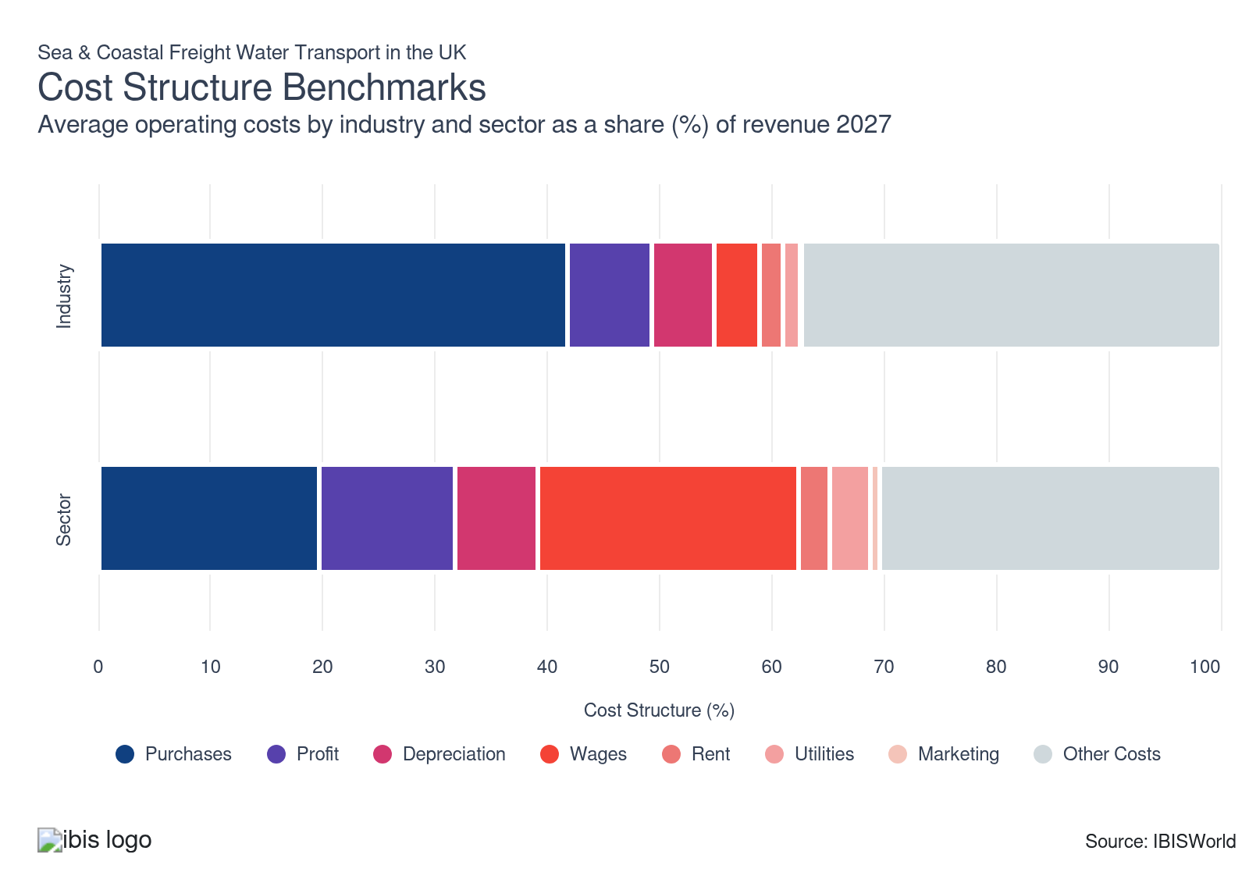
Chart displays current year only in the PDF version of this report. You can view and download chart for all other years associated with this industry on my.ibisworld.com.

What trends impact industry costs?

Volatile operating conditions pressure profit
- Profitability in the sea and coastal freight water transport industry is under pressure, amid geopolitical uncertainty, leading to a modest decline in 2026-27.
- Red Sea operational risk has intensified into 2026 following a ceasefire breakdown. The US-Iran conflict in February 2026 prompted Houthi forces to announce the resumption of attacks on Western-linked vessels. According to Xeneta chief analyst Peter Sand in March 2026, ocean carriers are unlikely to return to the Red Sea at scale for the rest of 2026, with plans for a phased return shelved. As ships reroute around Africa fuel consumption rises, increasing costs and constraining profit.
- According to BIMCO, in January 2026, Suez Canal tonnage remained 60% below pre-crisis levels, resulting in longer voyages and higher operating expenses, maintaining downward pressure on profit.

Oil market disruption elevates purchase costs
- Fuel purchases remain the largest and most volatile input cost for shipping companies, and costs are rising in 2026-27. Escalating tensions linked to the conflict between the United States and Iran from late February 2026 have raised concerns over supply disruptions through the Strait of Hormuz. According to Ship & Bunker, VLSFO bunker prices rose to around US$982 (£728.61) per tonne as of 10 April 2026, almost doubling from the US$499 (370.24) level seen on 12 January 2026.
- Freight water companies have adopted more sophisticated ways of managing fuel expenses. Advanced optimisation techniques, like weather routing and just-in-time bunkering, can reduce fuel use by 10-20% compared to basic operation, according to the International Maritime Organisation in 2022. This management has reduced the impact of higher fuel prices, with purchase costs rising only modestly.

Depreciation expenses mount amid environmental regulatory changes
- Freight water transport vessels typically have longer lives and slower depreciation rates compared to assets in the wider transport sector. However, depreciation expenses have climbed modestly during the five years through 202-27 due to mounting regulatory demands.
- The implementation of the Merchant Shipping Regulation (Anti-fouling Systems) in May 2024 requires vessel owners to retrofit existing fleets or acquire new vessels free of harmful coatings, driving up capital investment and inflating depreciation charges.
- The introduction of FuelEU Maritime from January 2025 mandates a 2% reduction in greenhouse gas intensity in 2025, with more drastic cuts to come. This forces freight water transport companies to invest in dual-fuel engines and alternative fuel systems, increasing both capital requirements and ongoing depreciation costs.

Wages remain stable despite tighter labour regulations
- The average industry wage is high, reflecting the skills required to operate vessels, though salaries vary between companies.
- In July 2022, following the P&O redundancy scandal, the government closed a loophole allowing seafarers who work on vessels that regularly serve UK ports to be paid below the UK minimum wage because the vessel operates an international service. In October 2024, the government enhanced seafarer rights by amending the Employment Rights Bill, introducing stricter rules on dismissals to protect workers. These changes have made it harder for shipping companies to cut wage costs by subcontracting cheap labour.
- In April 2026, the government raised the National Living Wage (NLW) by 4.1% to £12.71, exerting upward pressure on wages. Despite this, wage costs have remained stable in 2026-27, as companies have improved operational efficiencies and expanded their use of subcontracted labour where possible to offset the NLW hike.

High warehouse prices ratchet up rent costs
- Sea and coastal freight companies lease offices, warehouses, vessels, port spaces and related equipment essential for transporting and handling cargo.
- In recent years, inflationary pressures and port congestion have caused rent costs to expand, with rent costs gaining modestly in 2026-27. According to Kuehne+Nagel, in March 2026, yard utilisation at Southampton stood at 68% for dry cargo and 78% for reefers, with significant congestion from vessel delays expected to persist.
- Proximity to ports has become highly valued, leading to a rise in warehouse rents near major UK ports. According to a Savills report in 2023, industrial submarkets close to ports are seeing rents up to 63% higher than those in areas located 40-60 miles away, lifting the industry’s operating overheads.

Utility costs remain stable despite energy price volatility
- Utility expenses in the industry encompass essential services including water, electricity and gas. These are vital for operating vessels and maintaining the functionality of offices, warehouses and port facilities.
- Although global energy prices have been inflated in recent years, the industry’s utility costs have remained stable in 2026-27. This is due to measures aimed at improving energy efficiency and the establishment of energy-saving targets by shipping companies to eliminate energy waste. For instance, in 2023, Evergreen Marine (UK) Ltd reduced utility costs by installing LED lights in its offices and replacing boilers with more energy-efficient installations.

Freight water companies don’t spend much on marketing
- Marketing costs are negligible and have remained flat over the past five years, as the industry operates on a business-to-business relationship model, relying on direct sales, contract negotiations and tender processes rather than large-scale advertising campaigns.
- Major trades such as container shipping and bulk transport secure business through procurement teams, slot-charter agreements and alliance partnerships. Customer acquisition and retention are driven by rate competitiveness, reliability and capacity, not brand advertising or promotions.
- As renewal decisions are based on service level and price, key account managers manage relationships after contracts are secured, reducing the need for marketing spend. This results in little to no competitive pressure to advertise, keeping marketing costs consistently low.

Other expenses rise with labour and insurance pressures
- Other costs, including subcontracted labour payments, insurance premiums and ongoing maintenance charges, have remained significant in the five years through 2026-27. Companies are turning more to agency labour to offset persistent wage inflation, particularly in the wake of regulatory changes.
- War risk insurance costs have surged for routes passing through high-risk regions like the Persian Gulf. According to Reuters in March 2026, war risk premiums for ships entering the Persian Gulf and the Strait of Hormuz surged from 0.25% to as high as 1-3.5% of hull value, with some broker estimates reaching 10%. This follows the outbreak of conflict between the US and Iran in February 2026.
- The UK Seafarers’ Wages Act 2023, effective from January 2025, enforces minimum wage parity on international services calling at UK ports, with penalties for non-compliance. This has fuelled a shift towards the greater use of subcontracted agency crew as companies seek to manage rapidly escalating labour costs within tightening regulatory frameworks.
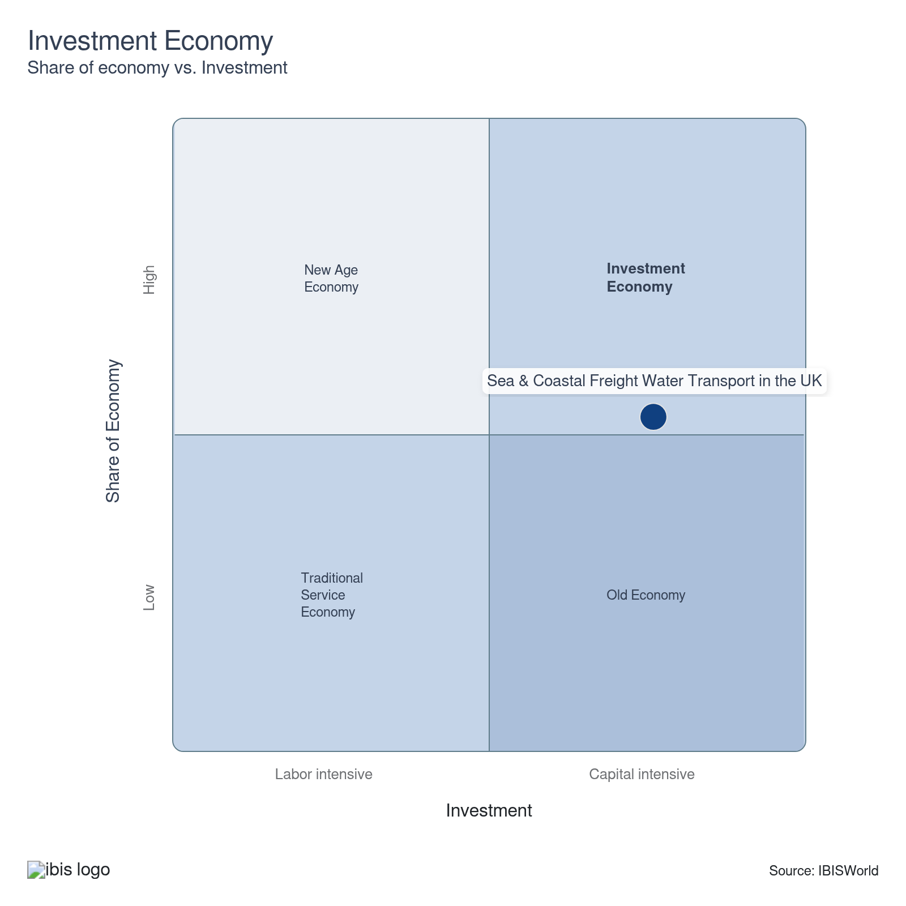

Financial Ratios

Liquidity Ratios
Ratio | Apr 21-Mar 22 | Apr 22-Mar 23 | Apr 23-Mar 24 | Apr 24-Mar 25 | Small  (<£10.2m) | Medium  (£10.2m-£36m) | Large  (>£36m)
Current Ratio | -9.9 | -27.9 | 9.4 | 4.7 | 4.2 | N/A | N/A
Day’s Payables | 97.4 | 344.0 | 66.0 | 217.7 | N/A | N/A | N/A
Days’ Inventory | 3.3 | 37.9 | 37.6 | N/A | N/A | N/A | N/A
Days’ Receivables | 108.8 | 62.3 | 29.1 | 17.3 | 0.1 | N/A | N/A
Inventory Turnover | 6716.3 | 1335.7 | 104.3 | N/A | N/A | N/A | N/A
Payables Turnover | 109.8 | 1,428.9 | 80.2 | 16.1 | 17.1 | N/A | N/A
Quick ratio (Acid test) | 3.6 | 3.0 | 8.3 | N/A | N/A | N/A | N/A
Trade Receivables Turnover | 10.5 | 38.8 | 859.2 | 1854.6 | 3698.6 | N/A | N/A
Working Capital Turnover | 13.2 | 12.4 | -101.8 | 23.4 | N/A | N/A | N/A

Coverage Ratios
Ratio | Apr 21-Mar 22 | Apr 22-Mar 23 | Apr 23-Mar 24 | Apr 24-Mar 25 | Small  (<£10.2m) | Medium  (£10.2m-£36m) | Large  (>£36m)
Cash Flow Coverage Ratio | N/A | N/A | N/A | N/A | N/A | N/A | N/A
Cash Flow Margin Ratio | N/A | -0.1 | N/A | N/A | N/A | N/A | N/A
Current Liability Coverage Ratio | -0.4 | 0.2 | 0.7 | N/A | N/A | N/A | N/A
Interest Coverage | 10265.5 | 915.5 | -196897.2 | 10.5 | 10.5 | N/A | N/A

Leverage Ratios
Ratio | Apr 21-Mar 22 | Apr 22-Mar 23 | Apr 23-Mar 24 | Apr 24-Mar 25 | Small  (<£10.2m) | Medium  (£10.2m-£36m) | Large  (>£36m)
Fixed Assets / Tangible Net Worth | 6.8 | 1.4 | 1333.9 | 7019.5 | 0.3 | N/A | N/A
Net Worth Ratio | N/A | N/A | N/A | N/A | -6.7 | N/A | N/A
Tangible debt / Tangible Net worth | 7.4 | 6.3 | 2.7 | 1.1 | N/A | N/A | N/A
Tangible Net Worth | 703431.3 | 1091898.6 | 776681.9 | 147246.5 | 0.3 | N/A | N/A
Total Debt / Net EBITDA | -11.7 | -9.1 | -4.8 | N/A | N/A | N/A | N/A
Total Debt / Tangible Net Worth | 7.4 | 6.3 | 2.7 | 1.1 | N/A | N/A | N/A

Operating Ratios
Ratio | Apr 21-Mar 22 | Apr 22-Mar 23 | Apr 23-Mar 24 | Apr 24-Mar 25 | Small  (<£10.2m) | Medium  (£10.2m-£36m) | Large  (>£36m)
Asset Turnover | 8.1 | 5.0 | 5.6 | 0.6 | 1.2 | N/A | N/A
Fixed Asset Turnover | 517.4 | 379.5 | 131.7 | 96.0 | N/A | N/A | N/A
Gross Profit / Turnover | 0.3 | 0.4 | 0.2 | 0.4 | 0.6 | N/A | N/A
Net Profit / Turnover | -0.2 | 0.1 | 0.3 | 0.1 | 0.2 | N/A | N/A
Return on total Assets (ROTA) | -0.1 | 0.1 | 2.2 | N/A | N/A | N/A | N/A

Assets, %
Ratio | Apr 21-Mar 22 | Apr 22-Mar 23 | Apr 23-Mar 24 | Apr 24-Mar 25 | Small  (<£10.2m) | Medium  (£10.2m-£36m) | Large  (>£36m)
Cash & Equivalents | -0.1 | N/A | 1.7 | 0.3 | 0.2 | N/A | N/A
Fixed Assets | 0.2 | 0.2 | 0.1 | 0.2 | N/A | N/A | N/A
Inventory | -0.3 | 0.1 | N/A | N/A | N/A | N/A | N/A
Total Assets | 1.0 | 1.0 | 1.0 | 1.0 | 1.0 | N/A | N/A
Total Assets (£m) | 1,439,608.2 | 2,554,700.1 | 2,845,308.6 | 281,078.3 | N/A | N/A | N/A
Total Current Assets | -0.7 | -0.4 | 1.7 | 0.9 | 1.1 | N/A | N/A
Trade Receivables (net) | -1.5 | 0.4 | -0.8 | 0.3 | N/A | N/A | N/A

Liabilities, %
Ratio | Apr 21-Mar 22 | Apr 22-Mar 23 | Apr 23-Mar 24 | Apr 24-Mar 25 | Small  (<£10.2m) | Medium  (£10.2m-£36m) | Large  (>£36m)
Long Term Debt | 0.1 | 0.2 | 0.3 | 0.2 | 0.4 | N/A | N/A
Net Worth | -79.5 | -0.9 | -3.1 | 0.4 | 0.3 | N/A | N/A
Short Term Debt | -60.7 | -0.7 | -3.2 | 0.6 | 0.4 | N/A | N/A
Total Current Liabilities | 0.4 | N/A | N/A | N/A | N/A | N/A | N/A
Total Liabilities & Net Worth (£m) | 1,439,608.2 | 2,554,700.1 | 2,845,308.6 | 281,078.3 | N/A | N/A | N/A
Trade Payables | -0.3 | -0.2 | 1.1 | -0.2 | 0.3 | N/A | N/A

Valuation Multiples

Valuation Multiples
Ratio | Apr 20-Mar 21 | Apr 21-Mar 22 | Apr 22-Mar 23 | Apr 23-Mar 24 | 3 Year Average | 5 Year Average
EV/Revenue | 0.1 | 0.2 | 0.2 | 0.3 | 0.2 | 0.2
EV/EBITDA | 1.4 | 3.9 | 4.3 | 3.1 | 3.8 | 3.2
EV/EBIT | 1.4 | 3.9 | 4.3 | 3.1 | 3.8 | 3.2

Key Ratios
Year | Revenue per Employee  (£) | Revenue per Enterprise  (£ Million) | Employees per Estab.  (Units) | Employees per Enterprise  (Units) | Average Wage  (£) | Wages/ Revenue  (%) | Estab. per Enterprise  (Units) | IVA/ Revenue  (%)
1999-00 | N/A | N/A | N/A | N/A | N/A | N/A | N/A | N/A
2013-14 | 1,215,208 | 10.9 | 8.2 | 8.9 | 59,588 | 4.9 | 1.1 | 10.6
2014-15 | 1,100,000 | 10.2 | 8.5 | 9.2 | 59,004 | 5.4 | 1.1 | 17.4
2015-16 | 1,023,487 | 9.7 | 8.9 | 9.5 | 57,329 | 5.6 | 1.1 | 17.1
2016-17 | 1,071,483 | 10.5 | 9.1 | 9.8 | 56,339 | 5.3 | 1.1 | 17.5
2017-18 | 1,191,597 | 11.5 | 9.3 | 9.7 | 56,327 | 4.7 | 1.0 | 16.3
2018-19 | 1,195,926 | 11.9 | 9.2 | 9.9 | 55,936 | 4.7 | 1.1 | 16.2
2019-20 | 1,294,746 | 12.8 | 9.2 | 9.9 | 54,664 | 4.2 | 1.1 | 16.1
2020-21 | 1,230,734 | 11.1 | 8.9 | 9.0 | 52,921 | 4.3 | 1.0 | 15.6
2021-22 | 1,219,696 | 11.4 | 9.1 | 9.4 | 53,150 | 4.4 | 1.0 | 16.7
2022-23 | 1,220,897 | 11.8 | 9.4 | 9.7 | 50,792 | 4.2 | 1.0 | 17.0
2023-24 | 1,187,899 | 11.7 | 9.4 | 9.8 | 48,944 | 4.1 | 1.0 | 16.8
2024-25 | 1,160,039 | 11.5 | 9.5 | 10.0 | 47,720 | 4.1 | 1.0 | 17.0
2025-26 | 1,136,138 | 11.4 | 9.6 | 10.0 | 46,688 | 4.1 | 1.0 | 17.1
2026-27 | 1,134,294 | 11.5 | 9.8 | 10.1 | 46,534 | 4.1 | 1.0 | 17.1
2027-28 | 1,115,346 | 11.5 | 9.9 | 10.3 | 45,827 | 4.1 | 1.0 | 17.3
2028-29 | 1,066,941 | 11.1 | 10.0 | 10.4 | 44,038 | 4.1 | 1.0 | 17.5
2029-30 | 1,070,119 | 11.1 | 10.0 | 10.4 | 44,154 | 4.1 | 1.0 | 18.6
2030-31 | 1,092,627 | 11.4 | 10.1 | 10.4 | 45,001 | 4.1 | 1.0 | 18.9
2031-32 | 1,092,085 | 11.4 | 10.2 | 10.5 | 44,972 | 4.1 | 1.0 | 19.2
2032-33 | 1,119,994 | 11.7 | 10.2 | 10.4 | 46,010 | 4.1 | 1.0 | 19.5
*Figures are inflation adjusted to 2026
*Figures are inflation adjusted to 2026

10. Key Statistics
https://my.ibisworld.com/uk/en/industry/H50.200/key-statistics

Industry Data

Values
Year | Revenue  (£ Million) | IVA  (£ Million) | Estab.  (Units) | Enterprises  (Units) | Employment  (Units) | Wages  (£ Million)
1999-00 | N/A | N/A | N/A | N/A | N/A | N/A
2013-14 | 7,164.9 | 761.6 | 716 | 659 | 5,896 | 351.3
2014-15 | 6,416.3 | 1,115.6 | 683 | 631 | 5,833 | 344.2
2015-16 | 5,850.3 | 998.2 | 644 | 601 | 5,716 | 327.7
2016-17 | 6,293.9 | 1,103.7 | 646 | 598 | 5,874 | 330.9
2017-18 | 6,950.6 | 1,134.5 | 628 | 602 | 5,833 | 328.6
2018-19 | 7,034.4 | 1,143.0 | 639 | 592 | 5,882 | 329.0
2019-20 | 7,576.9 | 1,219.4 | 635 | 594 | 5,852 | 319.9
2020-21 | 6,707.5 | 1,044.5 | 613 | 607 | 5,450 | 288.4
2021-22 | 6,879.1 | 1,145.9 | 620 | 603 | 5,640 | 299.8
2022-23 | 7,270.4 | 1,233.1 | 632 | 615 | 5,955 | 302.5
2023-24 | 7,230.7 | 1,216.2 | 645 | 620 | 6,087 | 297.9
2024-25 | 7,216.6 | 1,227.9 | 655 | 625 | 6,221 | 296.9
2025-26 | 7,169.0 | 1,226.6 | 656 | 629 | 6,310 | 294.6
2026-27 | 7,395.6 | 1,264.8 | 665 | 643 | 6,520 | 303.4
2027-28 | 7,376.9 | 1,276.9 | 666 | 644 | 6,614 | 303.1
2028-29 | 7,006.6 | 1,228.1 | 657 | 634 | 6,567 | 289.2
2029-30 | 7,130.2 | 1,324.6 | 663 | 640 | 6,663 | 294.2
2030-31 | 7,453.9 | 1,407.1 | 673 | 655 | 6,822 | 307.0
2031-32 | 7,547.4 | 1,448.0 | 679 | 661 | 6,911 | 310.8
2032-33 | 7,943.0 | 1,547.4 | 694 | 679 | 7,092 | 326.3

*Figures are inflation adjusted to 2026

Annual Change
Year | Revenue  % | IVA  % | Estab.  % | Enterprises  % | Employment  % | Wages  %
1999-00 | N/A | N/A | N/A | N/A | N/A | N/A
2013-14 | N/A | N/A | N/A | N/A | N/A | N/A
2014-15 | -10.4 | 46.5 | -4.6 | -4.2 | -1.1 | -2.0
2015-16 | -8.8 | -10.5 | -5.7 | -4.8 | -2.0 | -4.8
2016-17 | 7.6 | 10.6 | 0.3 | -0.5 | 2.8 | 1.0
2017-18 | 10.4 | 2.8 | -2.8 | 0.7 | -0.7 | -0.7
2018-19 | 1.2 | 0.7 | 1.8 | -1.7 | 0.8 | 0.1
2019-20 | 7.7 | 6.7 | -0.6 | 0.3 | -0.5 | -2.8
2020-21 | -11.5 | -14.3 | -3.5 | 2.2 | -6.9 | -9.8
2021-22 | 2.6 | 9.7 | 1.1 | -0.7 | 3.5 | 3.9
2022-23 | 5.7 | 7.6 | 1.9 | 2.0 | 5.6 | 0.9
2023-24 | -0.5 | -1.4 | 2.1 | 0.8 | 2.2 | -1.5
2024-25 | -0.2 | 1.0 | 1.6 | 0.8 | 2.2 | -0.4
2025-26 | -0.7 | -0.1 | 0.2 | 0.6 | 1.4 | -0.8
2026-27 | 3.2 | 3.1 | 1.4 | 2.2 | 3.3 | 3.0
2027-28 | -0.3 | 1.0 | 0.2 | 0.2 | 1.4 | -0.1
2028-29 | -5.0 | -3.8 | -1.4 | -1.6 | -0.7 | -4.6
2029-30 | 1.8 | 7.9 | 0.9 | 0.9 | 1.5 | 1.7
2030-31 | 4.5 | 6.2 | 1.5 | 2.3 | 2.4 | 4.4
2031-32 | 1.3 | 2.9 | 0.9 | 0.9 | 1.3 | 1.2
2032-33 | 5.2 | 6.9 | 2.2 | 2.7 | 2.6 | 5.0

*Figures are inflation adjusted to 2026

DISCLAIMER
This product has been supplied by IBISWorld Ltd. (‘IBISWorld’) solely for use by its authorised licensees strictly in accordance with their licence agreements with IBISWorld. IBISWorld makes no representation to any other person with regard to the completeness or accuracy of the data or information contained herein, and it accepts no responsibility and disclaims all liability (save for liability that cannot be lawfully disclaimed) for loss or damage whatsoever suffered or incurred by any other person resulting from the use of, or reliance upon, the data or information contained herein. Copyright in this publication is owned by IBISWorld Ltd. The publication is sold on the basis that the purchaser agrees not to copy the material contained within it for other than the purchaser’s own purposes. In the event that the purchaser uses or quotes from the material in this publication – in papers, reports or opinions prepared for any other person – it is agreed that it will be sourced to IBISWorld Ltd

